CHESS 17 August 2024 David Ellis [ellisd19@bigpond.com](mailto:ellisd19@bigpond.com) 043979860

 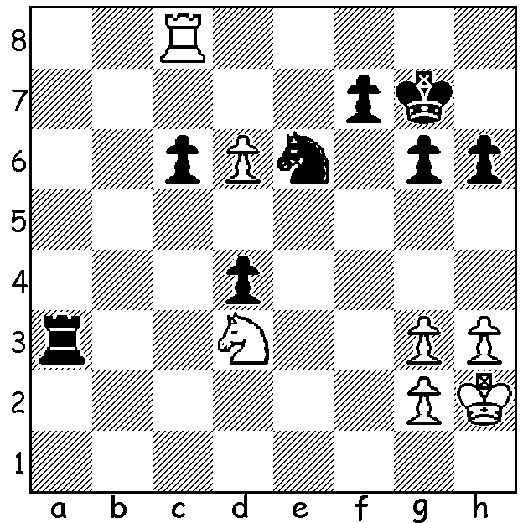

**Tan Zhongyi** (pictured) **vs Shen Yung, 2009:** White to play and win.

**CHESS, WHY ARE MALES BETTER?**

Last week I wrote about the large number of current Grandmasters there are, close to 2000. Of these only 42 are women. This contrast is only slightly less pronounced in the total number of players with only 11% of FIDE rated players female. So why this vast discrepancy? Many reasons have been offered, most with valid arguments. It has been said that males are better than females in traits more likely to lead to success in chess. These include spatial ability, degree of aggression, drive to win and ‘obsessive passion’ in the realm of sport which lead to monomaniacal focus on training and practice. With a more competitive nature the male is more likely to choose games that are individual and involve direct confrontation. There is also sex discrimination with parents more likely to encourage their sons to learn and play the game. I must admit I was guilty in this regard, teaching my son when he was three but later having to be asked by my primary school daughter to take her with me to a junior club I ran. Both had their successes with my daughter not only playing for the WA Girl’s team but also the WA Women’s team and competing in an Australian Championship. Finally, parenthood may be the reason may women give up Chess, while fathers can more easily continue playing.

Today in Chess while the major events are Open there are often separate events for females. The first women’s international tournament took place in London in 1897. As in other sports Chess has had to make a decision regarding transgender players. Like many other sports organisations FIDE does not allow transgender (M to F) players to play in female events.

**SOLUTION**: 1.d7! Rxd6 2.Re8! and Black has no answer to 3.Rxe6! followed by queening. Tan Zhongyi was Womens World Champion 2017-18.