CHESS 24 August 2024 David Ellis [ellisd19@bigpond.com](mailto:ellisd19@bigpond.com) 043979860



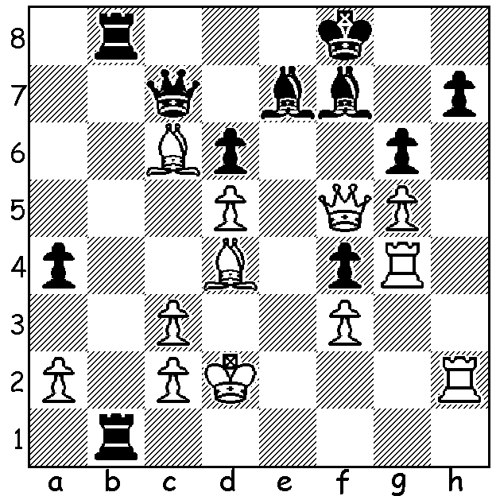

**Alexandra Kosteniuk** (pictured) **vs John Bick, 2003:** White mates in 7.

**CHESS, FEMALE TRAILBLAZERS**

Last week I wrote about how few females have succeeded in Chess. One of the earliest was Maria Teresa Mora (1902-1980). Born in Havana, Maria was considered a child prodigy in various fields including Music as well as Chess. Taught by her father, she soon was able to defeat him. She then became a student of the president of the Havana Chess Club for several years. At eleven in her first tournament at the Havana Club she finished in first place. She was noticed by world champion Jose Raul Capablanca who offered to coach her, an offer never extended to anyone else. In 1922, the only woman in the event, she won the Cuban Championship. She won the Cuban Womens Championship in 1938 and successfully defended the title for 22 years before retiring. She also played in two Women’s World Championships, 1939 Buenos Aires scoring 11/19 and 1950 Moscow 6/15.

**ENGLISH GIRL SENSATION**

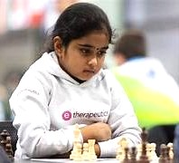During COVID lockdown a young girl found an old

chess set which her father was intending to throw away.

This little girl, born in March 2015 and called Bodhana

Sivanandan, has become the youngest ever English

international, having been selected for her country’s

women’s team in the forthcoming Olympiad. Among

her successes are world age titles, 2023 UK Womens

Blitz Champion, 2023 Womens Blitz Champion with

8.5/13 in the European Blitz Championships (Open)

in which a number of GMs were competing.

**SOLUTION**: 1.Qxf7+! Kxf7 2.Rxh7+ Kg8 3.Rh8+ Kf7 4.Rxf4+ Bf6 5.Rxf6+ Ke7 6.Rh7+ Kd8 Rf8#. Alexandra Kosteniuk was Woemens World Champion 2008-10.