CHESS 31 August 2024 David Ellis [ellisd19@bigpond.com](mailto:ellisd19@bigpond.com) 043979860

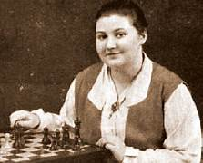

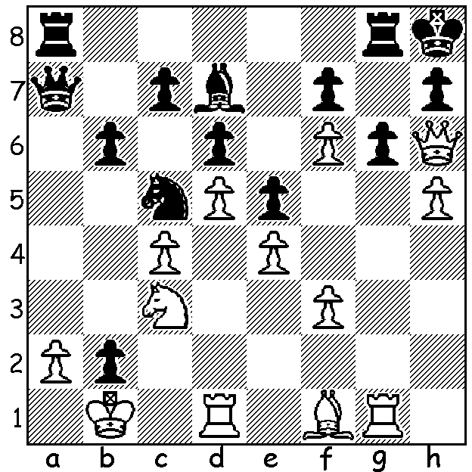

**Vera Menchik** *(pictured)* **vs**

**Sir George Thomas 1932**

White mates quickly

**WOMEN TRAILBALZERS II**

**Vera Menchik** (1906-1944) was the first women to participate regularly in tournaments with the leading players of the day. Born in Moscow, she moved with her mother and sister (also a successful player) to England in 1921 where she joined the famous Hastings Chess Club. Her coaches were Hastings club champion James Drewitt, and then Geza Maroczy. By 1925 she had established herself as the best female player in the country by beating the British women’s champion in two matches and then in 1927 she won the inaugural Womens World Championship, a title she held until her death, defending the title in both tournaments and matches. She began competing in top level tournaments in 1928 and, following her big success at Ramsgate, England, where she shared second place with Akiba Rubinstein, a half point behind former world champion Jose Raul Capablanca, she was regularly invited to elite events around Europe. Although rarely challenging for any of the top places she did defeat a number of top players – two victories and a positive score against Max Euwe (world champion 1935), a positive score in the 29 games against Sir George Thomas and wins against other British Champions Fred Yates, Mir Sultan Khan, Harry Golembek and C H O’D Alexander, as well as victories over Samuel Reshevsky, Edgard Colle and Eugene Znosko-Borovsky. In 1944, together with her sister and mother, she was killed when her house in London was destroyed by one of the earliest V-1 flying bombs. The trophy for the winning team at the Womens Chess Olympiad is named the Vera Menchik Cup in her honour.

**SOLUTION:** 1.hxg fxg 2.Qxh7+! Kxh7 3.Rh1#