CHESS 7 September 2024 David Ellis ellisd19@bigpond.com 043979860

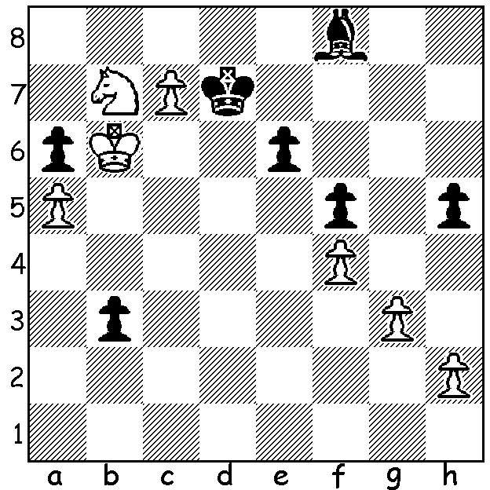
Fabiano Caruana vs Anish Giri Players in 2024 Sinquefield.
White to play. Who wins? Can you recognise them?

WORLD CHAMPION AGAIN DISAPPOINTS
The annual Sinquefield Cup, played in St Louis, USA, August 19 to 29, was another chance for World Champion Ding Liren to get back into form before his title match against Gukesh Dommaraju starting November 20. However Ding had another disappointing tournament finishing second last with 3.5/9. The winner Alireza Firouzja, unbeaten on 6/9, had previously won in 2022 and his success meant he was also winner of the 2024 Grand Chess Tour ahead of Fabiano Caruana and Maxime Vachier-Lagrave. Other Sinquefield scores: Caruana 5.5, Nodirbek Abdusattarov and MLV 5, Wesley So, Praggnannandhaa and Gukesh 4.5, Ian Nepomniachtchi and Ding 3.5, Anish Giri 3.

The WILLETTON OPEN
The Willetton Open, played 17/18 August at Canning Bridge
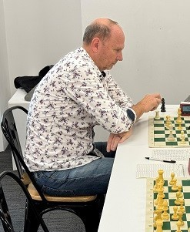
Community Space, was won by Gyula Plaganyi (5.5/6) closely
followed by Kathryn Hardegen on 5. =1st Under 1800 winners
were Abhimav Varma and Gary Donaldson on 4 and Under 1500
winner was Angus Chen with 3.5.

The SOUTH WEST CHESS FESTIVAL
After the event was successfully introduced last year, organisers
hope for an even better turn out this year in Margaret River,
14 & 15 September, with tournaments in both regular 60 min +10
sec and Rapid 25 min + 10 sec time controls.

For entry and additional info see cawa.org.au (Calendar). Gyula Plaganyi

SOLUTION: 1.Nc5+! (clearance sacrifice); if 1…Bxc5+ 2. Kb7 and queens, Black was forced to play 1…Kb8 allowing the capture of his dangerous passed pawn and leaving him with a lost game. Players: R-L top - Giri, Gukesh, Ding, Pragg, MVL; R-L bottom – So, Abdusattarov, Nepo, Firouzja, Caruana

