CHESS 14 September 2024 David Ellis [ellisd19@bigpond.com](mailto:ellisd19@bigpond.com) 043979860

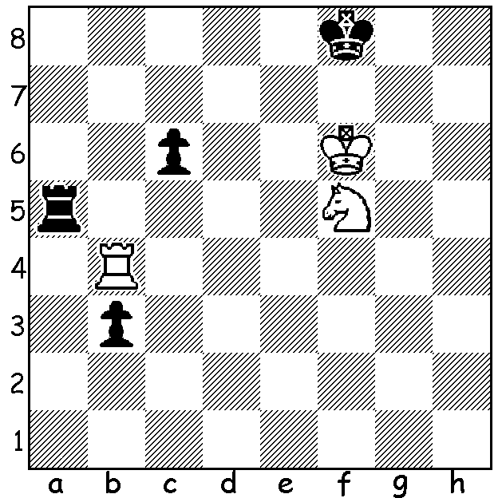

**Alireza Firouzja vs**

**Hikaru Nakamura**

(World Speed Ch 2024)

Black now plays 1…Rb5.

Why is this a blunder and

what should be played?

**FIROUZJA FALLS AT FINAL HURDLE**

 The **World Speed Chess Championship,** played in Paris

July 25 to September 9, was a 16-player knock-out, and was

expected to result in another final between the world’s top

two speed players, **Magnus Carlsen** and **Hikaru Nakamura**

who had between them won the event every time since its

inception (Carlsen 2016 & 2017, Nakamura 2018 – 2023).

However another final between these two rivals was not to

be with **Nakamura** losing his semi-final to **Alireza Firouzja**

11-16 while **Carlsen** defeated **Hans Niemann** 17.5 – 12.5.

Readers will be aware of the animosity between these two

players after Carlsen accused Niemann of cheating after

losing a game to him in 2022.

The format throughout was three 90 min sessions with time

limits 5min + 1sec, then 3min + 1sec and finally 1min + 1sec.

Moves are played on computers which avoids players

knocking over pieces in their haste.

Firouzja, the Iranian/French star, has had a very successful

2024, winning the Chess.com Bullet Championship, defeating

Nakamura in the final, the St Louis Rapid & Blitz and the

recent Sinquefield Cup, and his match against Carlsen in the

final was expected to be close. **Carlsen**, however, showed

why he remains number 1 with an emphatic 23.5 – 7.5 victory.

In the play-off for 3rd **Nakamura**, who had expressed strong

support of Carlsen for his accusations of cheating, trounced

**Niemann** 21-9. Now wouldn’t that tournament have been a

wonderful part of the Paris Olympics?

**SOLUTION:** While 1…Rb5? prevents immediate mate and threatens to queen the b pawn, White renews his mate threat with 2.Ra4 and Black is lost: if 2…Ke8 3.Nd6+ forks K & R, 2…Kg8 3.Ne7+ Kh7 Rh4# while 2…Rb8 (played) loses to 3.Rh4 (3,,,Kg8 4.Ne7+ Kf8 5.Rh8#.) Black should play 1…Ke8 giving him an escape from the mate threat.