CHESS 28 September 2024 David Ellis [ellisd19@bigpond.com](mailto:ellisd19@bigpond.com) 043979860

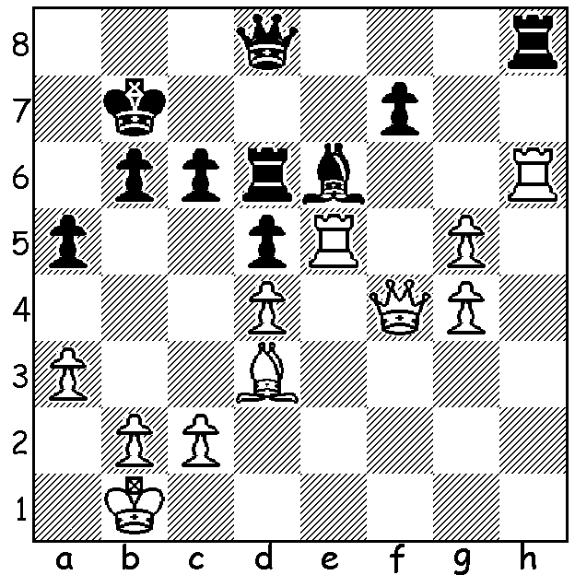

**Divya Dashmukh**

**vs Ni Chiqun,**

India vs China,

45th Olympiad 2024.

Black has just played

…Rd7-d6.

Why does this lose?

**DOUBLE SUCCESS FOR INDIA AT OLYMPIAD**

Despite late hiccups in both sections, India became, after Russia in 1998 and China in 2114, winners of both the Open and Womens Olympiad, played in Budapest, Hungary. The Indian Open team won 10 and drew one match (v Uzbekistan, Rd 9) while their women won nine matches, lost one (v Poland, Rd 8) and drew one (v USA, Rd 9) The Open team finished well ahead with 21/22 match points, only losing a single game for the tournament (Pragg to American Wesley So). Second, with game points deciding, was top-rated team USA 2nd on 17, ahead of 3rd placed Uzbekistan, also 17 pts. China, Serbia and Armenia were next, also scoring 17. Indian players’ scores: Gukesh 9/10, Pragg 6/10, Arjun Erigaisi 10/11, Vidit 7.5/10 and Pentala Harikrishna 2.5/3. The Indian women came into the final round level with Kazakhstan but defeated Azerbaijan 3.5 – 0.5 while their rivals could only draw with USA. Team scores: India 19, Kazakhstan 18, USA 17.

Australia’s two teams both performed well with the Open team scoring 6 wins, 1 draw and 4 losses, coming in a group of 16 teams on 13/22 (41st – 56th of 188 teams) while the women scored 6 wins, 2 draws and 3 losses in a group of 15 teams on 14 (22nd – 36th of 170 teams). While both our players on Board 1, West Australian Temur Kuybokarov (3,5/8) and Julia Ryjanova (3.5/9), had difficult tournaments, Bobby Chang on Open Bd 2 (7/9), Zhang Jilin on women’s Bd 2 (6.5/9) and Zhiyuan Shen on women’s Bd 4 (7/10) all had excellent results.

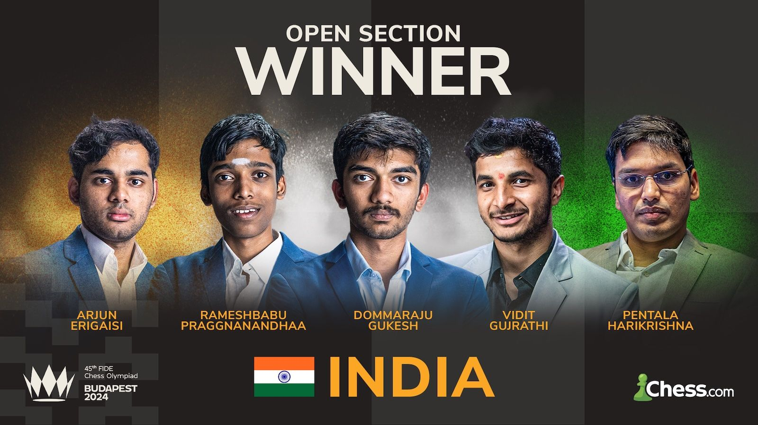

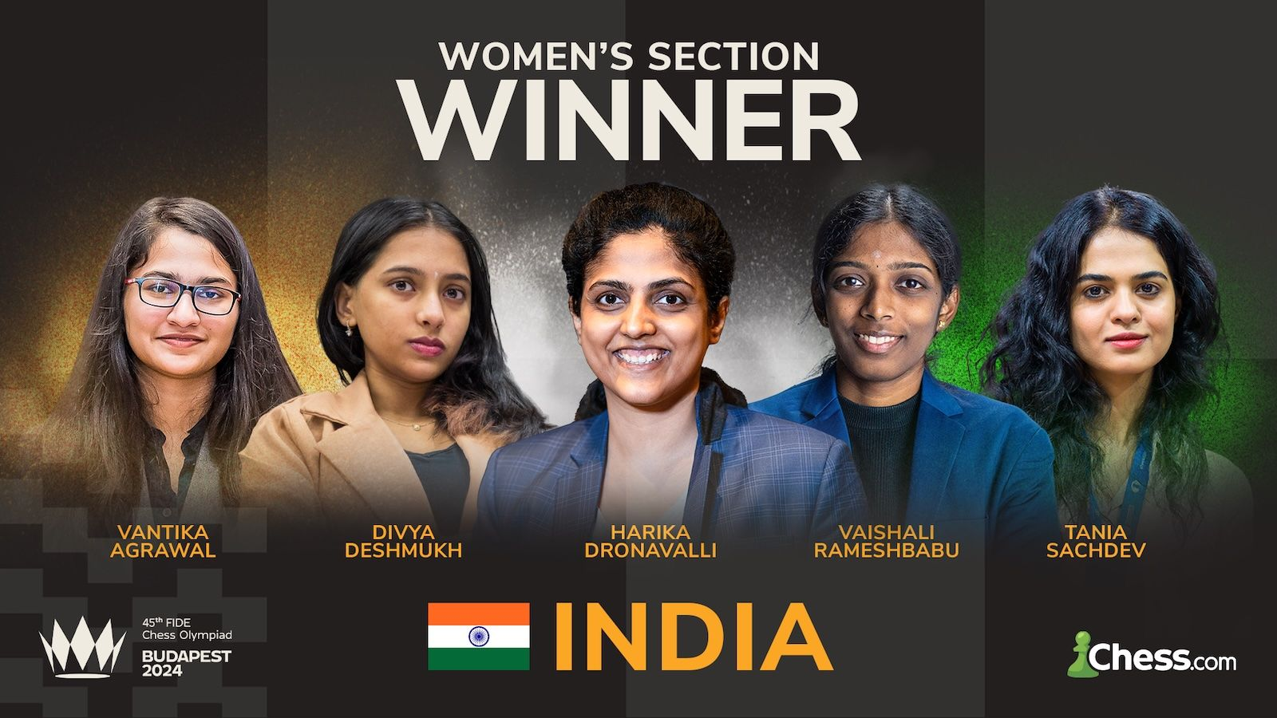

**SOLUTION:** Three tactical ideas come up in three moves, overworked piece, discovered attack and fork – 1.Rxh8 (deflecting the queen from protecting the rook) 1…Qxh8 2.Rxe6! (discovering an attack on the remaining rook) 2…Rxe6 3.Qxf7+ (forking king and rook) Black resigns. 18 year old Divya scored 9.5/11, a most valuable contribution to India’s overall victory which earned her the Bd 3 Individual Gold Medal.