CHESS 5 October 2024 David Ellis [ellisd19@bigpond.com](mailto:ellisd19@bigpond.com) 043979860

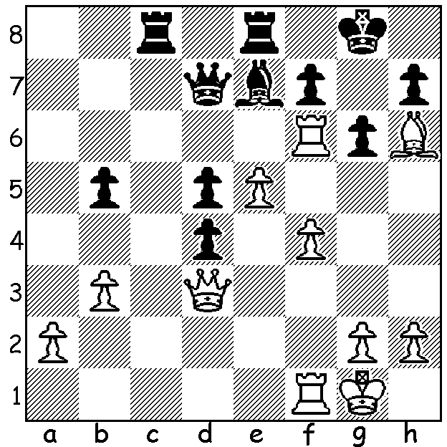

**Pia Cramling vs**

**Alexander Fishbein 1985:**

How does White break

through to mate?

**CHESS OLYMPIADS TRIVIA**

**FAMILY AFFAIRS**: there have been a number of close relatives playing in the Chess Olympiads over the years. This year brother and sister, Praggnanandhaa and Vaishali Ramashabu were key players in India’s top place in both the Open and Women’s competition while Sweden had three members of a family representing the country’s women’s team, mother Pia Cramling,

daughter Anna and Pia’s husband Juan

Bellon Lopez, a former Spanish champion,

who was the team’s captain. This was the

third Olympiad all three have been

involved together at the Olympiads. Pia

played her first Olympiad at just 15 years

old in 1978 and has represented Sweden

in 4 Open and 6 Women’s Olympiads,

winning gold on Bd 1 on three occasions.

Perhaps the most famous family

representation was the three Polgar *Juan Bellon Lopez, Anna Cramling Bellon*

sisters, Susan, Judit and Sofia (together *and Pia Cramling*

with Ildiko Madi) winning the Women’s Olympiad for Hungary in 1988 and 1990.

**YOUNGEST and OLDEST**: five girls aged nine competed in the 2024 Women’s Olympiad including Bodhana Sivanandan (England) while Daniel Combs (Guam) and Deborah Quickpen (Nigeria) at 12 were the youngest in the Open. The two oldest competitors were women, 83 year old Pauline Woodward, making her debut for Guernsey Women, who were also playing in their first Olympiad, and 81 year old Rani Hamid, a former British and Bangladeshi women’s champion who had a six game winning streak in Budapest.

**MOST SUCCESSFUL PLAYERS**: two players, Alexander Alekhine (Bd 1 France) in 1930 and Robert Gwaze (Bd 1 Zimbabwe) in 2002 both scored 9/9. Mikhail Tal (USSR) has the best overall score with 82/101.

**MOST OLYMPIADS**: Eugenio Torre (Philippines) played in 23 Olympiads between 1970 and 2016. For Australia Ian Rogers played in 14 Olympiads, 12 on Bd 1, only once failing to make a plus score.

**SOLUTION:** 1.e6! fxe6 2.Rxg6+! hxg6 (2…Kh8 3.Qxd4+) 3.Qxg6+ Kh8 4.Qg7#.