CHESS 19 October 2024 David Ellis [ellisd19@bigpond.com](mailto:ellisd19@bigpond.com) 043979860

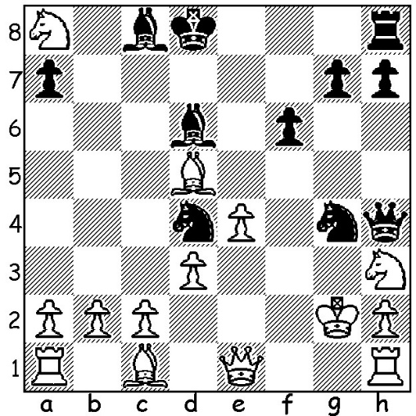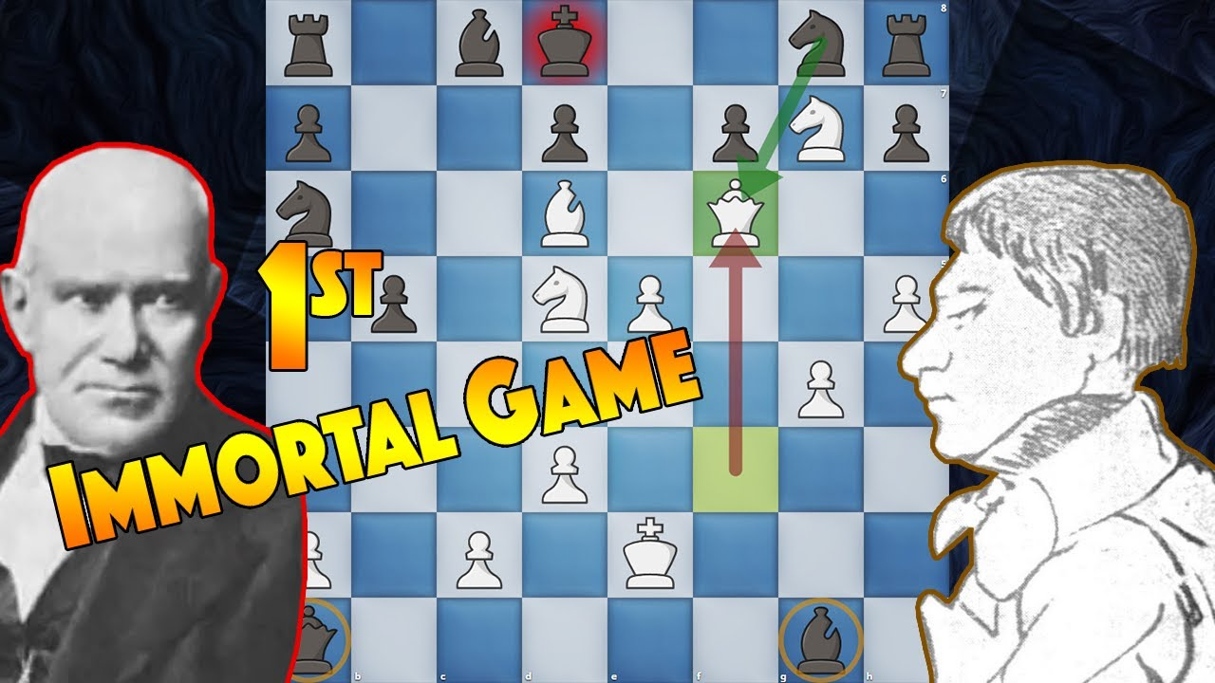

**John Schulten vs** *Adolf Anderssen (L)*

**Lionel Kieseritzky 1850:** *vs Lionel Kieseritzky*

Black to play mates in 5 moves.

**LIONEL KIESERITZKY**

Instead of being involved in tournaments most of the world’s top players are at present competing in team events. I am therefore reverting to my alphabet series on players giving their names to openings and with the letter K I have chosen Lionel Kieseritzky (1806 – 1853) who is best remembered for his loss to Adolf Anderssen in the ‘Immortal Game’(look it up if you are unfamiliar with it). Kieseritzky was born to a Baltic German family in the Russian Empire. He studied at university in Estonia and then worked as a mathematics teacher before moving to Paris to become a chess professional where he played or taught chess for five francs and hour and edited a chess magazine. Chessgames.com has 109 games of Kieseritzky, mainly match games, with a record of 60.7% (+54 =11 -33). His contribution to opening theory was considerable:

Kieseritzky Gambit, a variation of the Kings Gambit, 1.e4 e5 2.f4 exf 3.Nf3 g5 4.h4 g4 *5.Ne5:*

Boden-Kieseritzky Variation in the Vienna or Petroffs Defence, 1.e4 e5 2.Nc3 Nf6 3.Bc4 Nxe4 *4.Nf3* or 1.e4 e5 2.Nf3 Nf6 *3.Bc4 Nxe4 4.Nc3:*

Kieseritzky Variation in the Two Knights Defence, 1.e4 e5 2.Nf3 Nc6 3.Bc4 Nf6 4.Ng5 d5 5.cxd Na5 *6.d3.*

He is also credited with the invention of the first three-dimensional chess with an 8x8x8 cube format in 1853. He died in Paris and was buried in a pauper’s grave.

**SOLUTION:** 1…Qxh3+!! 2.Kxh3 Ne3+ 3.Kh4 Nf3+ 4.Kh5 Bg4# (3.Be6 Bxe6+ merely postpones the mate).