CHESS 26 October 2024 David Ellis [ellisd19@bigpond.com](mailto:ellisd19@bigpond.com) 043979860

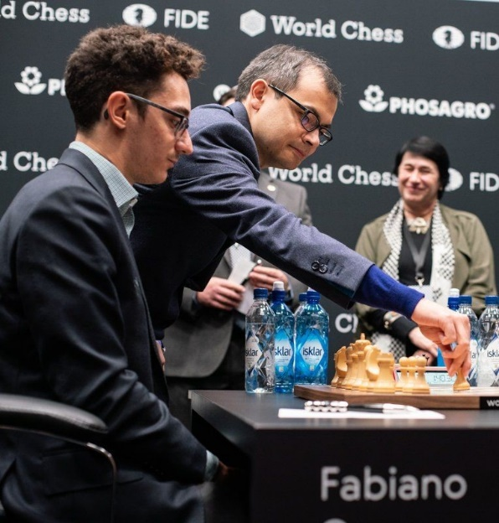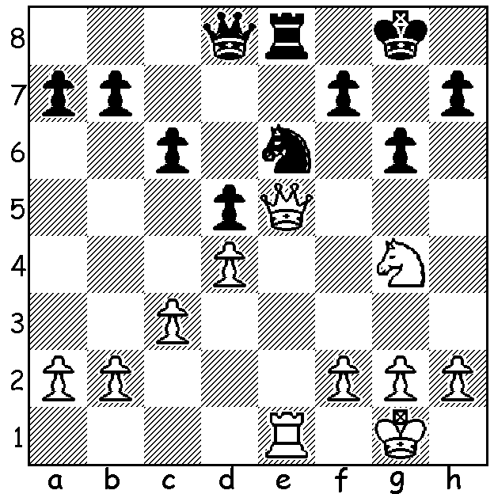

**Awonder Liang vs**

**Hans Niemann**

US Championship 2024: *Demis Hassabis making the first*

How does Black parry White’s threats *move at the World Championship*

(ingenuity needed from both sides to *in London* *between Fabiano*

reach a drawn position in 5 moves)? *Caruana and Magnus* *Carlsen*.

**THE GOOD, THE BAD AND THE UGLY.**

**The Good:** 48-year-old Demis Hassabis, a former chess prodigy and founder of DeepMind, a company that revolutionised computer chess, has won the 2024 Nobel for Chemistry (shared). Hassabis was once rated the second highest Under-14 in the world behind Judit Polgar. DeepMind, an artificial intelligence laboratory, produced Alpha-Zero, a self-learning programme that only needed to be fed the rules and four hours of playing against itself to become the world’s strongest chess computer. Hassabis believes chess is a window into human cognition, strategy and foresight and that the skills developed playing were important steps to his career in artificial intelligence.

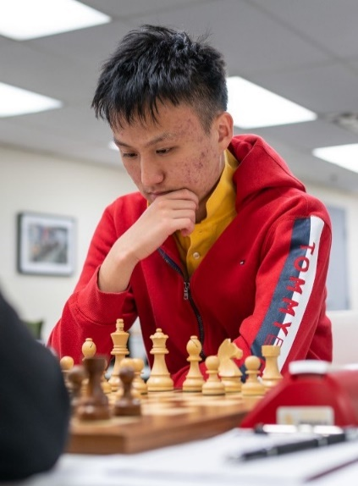**The Bad:** Twenty-two-year-old Krill Shevchenko, the current World No 69, rated over 2700, originally from Ukraine, was recently expelled from the Spanish Team Championship for using a mobile phone during a match, Lengthy absences from the board aroused suspicion and his mobile phone was discovered in the toilet.

**The Ugly:** 17-year-old Christopher Yoo was expelled from

the 2024 US Championship for serious breaches of the code

of conduct. In Rd 5 he lost to Fabiano Caruana after having

a considerable advantage, screwed up his scoresheet and was

alleged to have punched a female videographer from behind

when leaving the arena. He was arrested and charged before

being released to his parents. Yoo had earned his place in the

championship by winning the 2024 US Junior Championship.

**SOLUTION:** 1…Ng7!! 2.Qxe8+! (2.Nf6+? Qxf6!) 2…Nxe8

3.Rxe8+! Qxe8 4.Nf6+ Kf8 5.Nxe8 Kxe8=. Did you spot the

one flaw in White’s position, no escape for the king? *Yoo*