CHESS 2 November 2024 David Ellis [ellisd19@bigpond.com](mailto:ellisd19@bigpond.com) 043979860

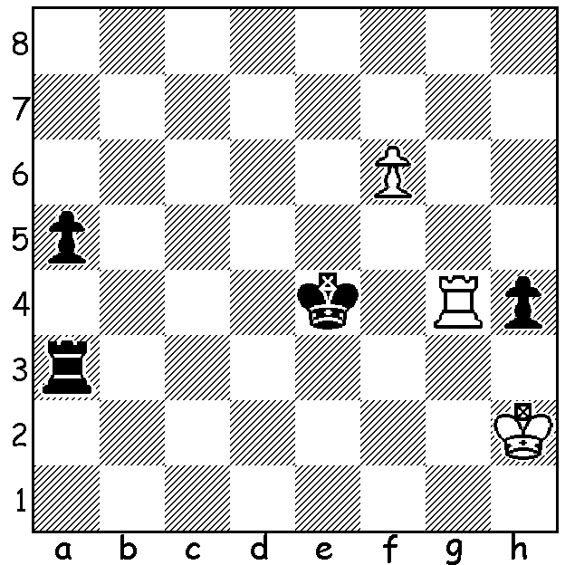

**Alice Lee vs**

**Gulrukbegim Tokhirjonova**

US WomensChampionship 2024:with Black to play what

shouldthe result be?

**ANOTHER FAB SUCCESS**

 **Fabiano Caruana** successfully defended his US title, winning the **US Championship** with a final round victory in St Louis against Sam Shankland to score 7/10 (+4 =6), a point and a half ahead of six players, Leiner Dominguez,

Levon Aronian, Hans Niemann, Ray Robson,

Samuel Sevian and Awonder Liang, all on 5.5/10.

Wesley So, winner in2017, 2020 & 2021, scored

5 (all drawn, his one win against the disqualified

Christopher Yoo did not count). Sam Shankland

scored 4, Grigory Oparin 3.5, Abhimanyu Mishra

2.5. Fifteen- year-old Mishra was the youngest

player ever to become a Grandmaster at 12 years

five months. At the start of the finalround Liang

was the only person other than Caruana with a chance *Caruana vs Shankland*

to take the title but he lost to Dominguez. Caruana has now

won the championship for the past three years (four times in

all) and intends competing in future championships, perhaps

to equal or surpass five-time winners Samuel Reshevsky,

Bobby Fischer and Hikaru Nakamura (among others).

The **US Womens Championship** was won comfortably by

**Carissa Yip** with 8.5/11, a point ahead of her nearest rival

Gulrubegim Tokhirjonova on7.5. Yip won her first eight

games and seemed in line for an additional prize of

US$64,000 if she could emulate Bobby Fischer and score

11/11. However a loss in Rd 9 dashed those hopes (she also

lost Rd 10 & drew Rd 11). Yip, aged 21, has won the title

for the past three years.  *Carissa Yip*

**SOLUTION:** The game should end in a draw but Black blundered with 1.Ke5? allowing 2.Rf4!! Now Black either loses her rook and is unable to defend her a pawn or allows White to queen. The game continued 2…Kxf4 3.f7 Kg4 4.f8=Q and wins. Black could have drawn with 1…Kd5! 2.Rf4 Rb3 3.f7 Rb8 4.f8=Q Rxf8 5.Rxf8 Kc4 and Black can defend and advance her a pawn which will cost White her rook.