CHESS 9 November 2024 David Ellis [ellisd19@bigpond.com](mailto:ellisd19@bigpond.com) 043979860

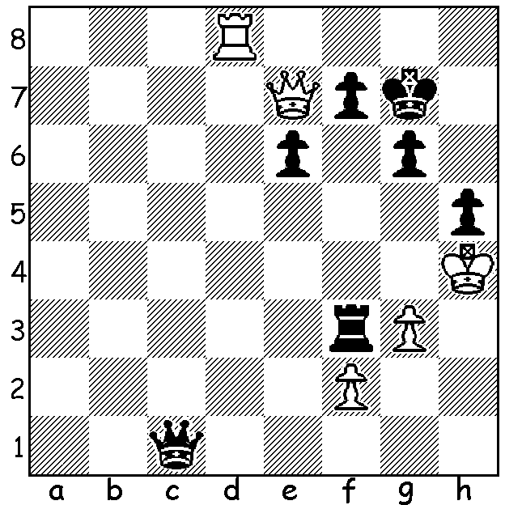

**Lazdies vs Zenitas**

**Riga 1936:**

White is in serious

trouble but obtains

an unlikely draw

(5 moves – moves

3,4 & 5 are !)

**LOCAL RESULTS**

**The WA SCHOOLS CHESS LEAGUE FINALS** were played at N Woodvale Primary 25 August with Rossmoyne Senior High convincing Secondary winner with 13/14 match points ahead of Perth Modern and Shenton College, both on 11/14, followed by Bob Hawke College, Duncraig Senior High, Trinity College, Wesley College & Melville Senior High. Board 1 prize went to Rui Gen Teh (6/6) while Cooper Scarff also had a 100% score (7/7 on Board 3). In the Primary competition Oberthur Primary was run-away winner with 12/12 match points, winning 22 games, drawing one and losing one. Angus Chen (5/6) gained the Board 1 prize with 5/6. Second in the Primary was Christchurch Grammar, followed by Dalkeith Primary, Nedlands Primary, Subiaco Primary & W Leederville Primary.

**The WA SCHOOLS CHESS LEAGUE FINALS (Girls)**

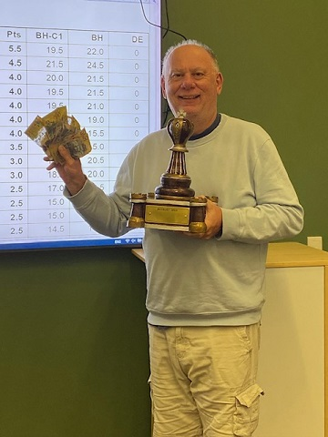were played on 14 September at Nedlands Primary with 14

schools represented. Winner of the Secondary was

Presbyterian Ladies College while Dalkeith Primary won

the Primary. Highest individual scores: Secondary Kobe

Wu (7/7) and Primary Senudi De Vas (7/7).

All four winning teams qualify to compete in the Australian

Schools Championship which will be held here in Perth at

Duncraig Senior High 7/8 December.

**The SOUTH WEST OPEN**, playedatthe Margaret River

Community Centre 14 & 15 September, gave entrants

the opportunity to compete in either Rapid or Classic.

Winner of the Classic section was Tim Hare with 5.5/6

(26 entrants) while Seamus MacLaughlin won the Rapid

with 6/6 (13 entrants).

*Tim Hare winner of both the*

**SOLUTION:** 1.Qf8+ Kf6 2.Qh8+ Kf5 3.g4+! hxg *Bunbury and South West Opens*

4.Rd5+! exd5 5.Qc8+! Qxc8.