CHESS 16 November 2024 David Ellis [ellisd19@bigpond.com](mailto:ellisd19@bigpond.com) 043979860

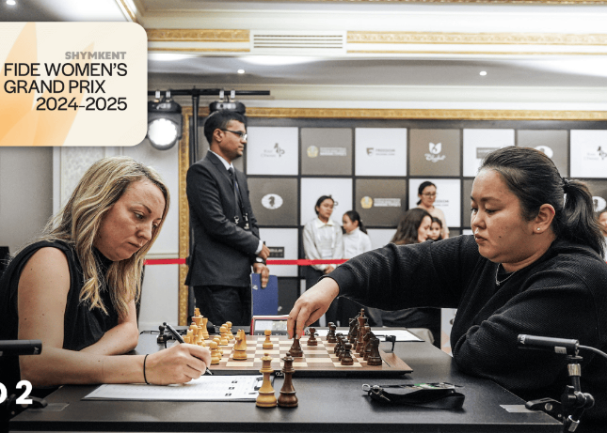

**Elisabeth Paehtz vs Batkhuyang Munguntuul** (Womens GP, Kazakhstan 2024):

White is attacking but resigns after Black’s next move;Can you see it?

**BREAKTHROUGH ACHIEVEMENT**

Afro-Americans have achieved incredible successes in

many sports - think Athletics and Basketball - but until

now no Afro-American born in USA has become a

Grandmaster. That is about to change when Brewington

Hardaway will officially receive the title at the next FIDE

Congress. Fifteen-year-old Hardaway had previously

gained the required three norms in tournament play,

before surmounting the final hurdle, a rating of 2500, by

scoring 3.5 from his first four games at the NY Fall

Invitational GM A. The first Afro-American GM was

Maurice Ashley, born in Jamaica, who gained his GM

title in 1999 aged 33. Hardaway texted Ashley to pass

on the news with Ashley commenting, “I had no doubt

he would do it … but the lack of African-American

representation at the highest level of Chess is still an

ongoing issue,” and cited the lack of resources for

African-American kids and a failure to provide sufficient *Brewington Hardaway*

support to ensure that talented Black kids can succeed.

**WOMENS GRAND PRIX IN KAZAKHSTAN**

The recent Women’s GP event in Shymkent was the second GP of six which will qualify two players to compete in the Womens Candidates. Winner was the only unbeaten player Alexsandra Goryachkina with 7/9. Russian Goryachkina is 26 and ranked 4th highest in women’s ratings. She lost in tie breaks to champion Ju Wenjun in a world title match in 2020. Second with 6.5 was Tan Zhongyi (China), aged 33, who was briefly Womens World Champion (2017-8) and is ranked third among women players.

**SOLUTION:** 1…Ba3!! White resigns. If 2.bxa3 Nc3 3.Bxc3 dxc3 with mate to come. It’s very rare to see a Grandmaster lose a game in 17 moves especially as White. Munguntuul is a mother of three and this was her first GP appearance in 12 years.