CHESS 23 November 2024 David Ellis [ellisd19@bigpond.com](mailto:ellisd19@bigpond.com) 043979860

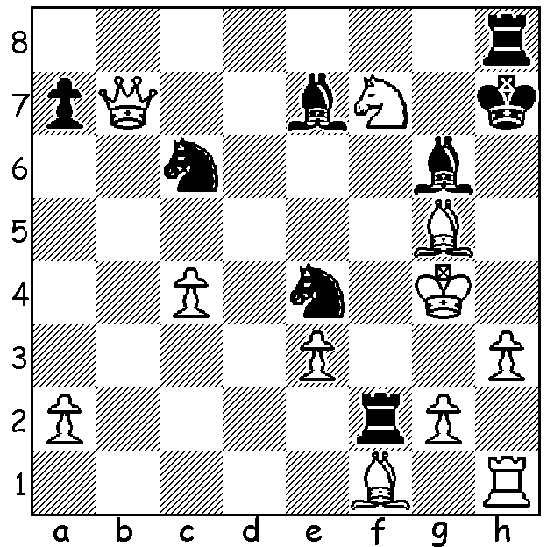

**Bai Jinshi vs Ding Liren, 2017;** *Ding vs Gukesh in an earlier encounter*

Black mates in 4. (move 1 is the !!)

**WORLD CHAMPIONSHIP ABOUT TO BEGIN**

The **World Championship** match between champion **Ding Liren** and challenger **Gukesh** **Dommaraju** begins in two days at Resorts World, Sentosa, Singapore and finishes on December 13. The match is over 14 Classic games with time controls of 40 moves in 120 min followed by 20 moves in next hour and then 15 min to end of game with 30 sec increments each move from move 61. No agreed draws are allowed before move 41. Prize money is US$2,500,000.

**Ding Liren,** 32 yrs, is China’s highest rated player ever and three times Chinese champion. In 2019 he won the Grand Chess Tour and the Sinquefield Cup. In 2023 he was ranked 1 in Rapid with 2830 rating. His present Classic rating is 2728, nearly 100 below his peak rating of 2816 in 2018. Ding went unbeaten for 100 games from August 2017 until November 2018 (+29 =71), a record only beaten by Magnus Carlsen in 2019. With Carlsen declining to defend the world title Ding, as runner-up in the 2022 Candidates, was given the opportunity to play a title match against Candidates winner Ian Nepomniachtchi. The regular Classic match finished 7-7 with Ding gaining the title with a 2.5-1.5 win in Rapid. It’s thought he was suffering from depression during the match and he took an extended break after winning but his results since a return to the board have been very sub-standard for a world champion, including finishing last and failing to win a game in some events.

Indian **Gukesh Dommaraju,** with a rating of 2783, is the youngest challenger in chess history at 18. Gukesh won the 2024 Candidates played in Toronto with 9/14, a half point ahead of Hikaru Nakamura, Nepo and Fabiano Caruana.

**SOLUTION:** 1…Ne5+!! (a queen down Black sacrifices a knight to deflect the White knight from covering h8 & g6) 2.Nxe5 Bf5+ 3.Kh5 Kg7+ 4. Bh6+ Rxh6#; if White declines the sacrifice with 2.Kh4 Kg8+! 3.Nxh8 Bxg5#. A fantastic attacking win!