CHESS 30 November 2024 David Ellis [ellisd19@bigpond.com](mailto:ellisd19@bigpond.com) 043979860

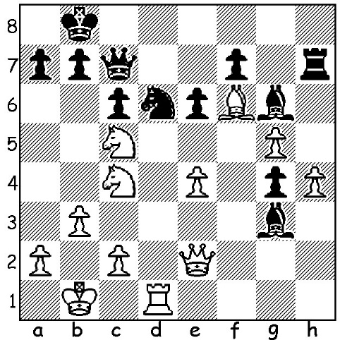

**Magnus Carlsen vs Praggnanandhaa:** *Magnus with his two Tata Steel trophies*

White to play and win (5 moves)

**HE’S STILL THE BEST**

While **Ding Liren** and **Gukesh Dommaraju** have been preparing for their world title match over 14 games in Singapore, Norwegian **Magnus Carlsen** was showing why he is still the Number 1 player in the world. He was first in both the 10-player Tata Steel India Rapidplay and the Blitz played in Kolkata Nov 13-17, scoring 7.5/9 in the Rapid and 13/18 in the Blitz. Praggnanandhaa (India) and Wesley So (USA) with 5.5 were second in the Rapid and Wesley So (USA) with 11.5 was second in the Blitz with Arjun Erigaisi (India) third with 10.5. As could be expected, the Blitz had a very high percentage of decisive results with many errors as well as a few outright blunders as well as players having extensive winning and losing streaks with the round-by-round tournament table becoming a Snakes and Ladders board.

In Singapore, as a supporting bout to the Ding-Gukesh world championship match, **Carlsen** played a two-game Freestyle (also called Fischer Random or 960 Chess) match against **Fabiano Caruana**. Carlsen won the match after winning the first game and holding Caruana to a draw in the second. For this Carlsen earned $60,000 while Caruana received $40,000, The match also promoted the 2025 Freestyle Chess Grand Slam with tournaments planned for Germany, France, USA, India and South Africa,

I imagine many WA players will now be following the Ding-Gukesh match live or with follow-up analysis of each game, especially as Perth and Singapore are in the same time zone. For only the second time ever Google is the major sponsor of a chess event. Audiences on line will be in the millions.

**SOLUTION:** Black’s last move …Nd6 is a blunder allowing 1.Nxd6 Bxd6 2.Rxd6!! Qxd6 3.Be5! Qxe5 4.Nd7+ Kc8 5.Nxe5.