CHESS 7 December 2024 David Ellis [ellisd19@bigpond.com](mailto:ellisd19@bigpond.com) 043979860

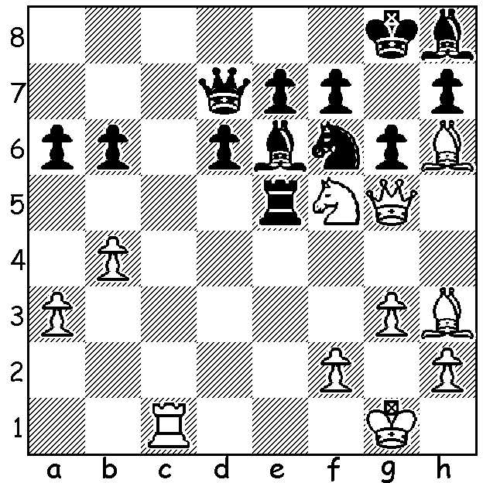

**Gukesh D vs Anastasya Paramzinia 2019:** White to play and win.

**CHALLENGER GUKESH DOMMARAJU**

The **Ding Liren** - **Gukesh Dommaraju** World Championship match being played at Resorts World, Sentosa, Singapore is due to finish on 13 December. I recently wrote about the two contestants concentrating mainly on the champion with space limitation preventing me from saying much about the challenger. Here then is a more detailed information on Gukesh.

Born May 2006, with his father an ear, nose and throat surgeon and his mother a microbiologist, Gukesh only learnt to play at seven but was soon practising for one hour three times a week and competing in tournaments at weekends. He won the Under-9 section of the 2015 Asian Schools Championships and the Under-12 section of the 2018 World Youth Championships. He became an International Master in 2017 and a Grandmaster in 2019 aged 12 years, 7 months and 17 days (at the time the second youngest). In the September 2023 rating list he overtook former world champion Vishhy Anand as India’s top-rated player.

Gukesh is the third youngest grandmaster in history as well as the third youngest to reach a rating of 2700 (considered super-GM). He is also the youngest Candidates winner (tournament to decide on a challenger to the world champion). He has won one team and two individual gold medals representing India at the chess Olympiads. In April this year he won the Candidates in Toronto, scoring 9/14, just ahead of Americans Fabiano Caruana and Hikaru Nakamura and Russian Ian Nepomniachtchi (playing under the FIDE flag), all with 8.5.

**SOLUTION:** 1.Rc8+! Qxc8 2.Nxe7#. If 1…Ne8 2.Nxe7+ wins the queen.