CHESS 19 April 2025 David Ellis [ellisd19@bigpond.com](mailto:ellisd19@bigpond.com) 043979860

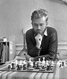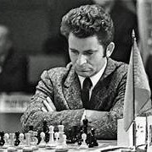  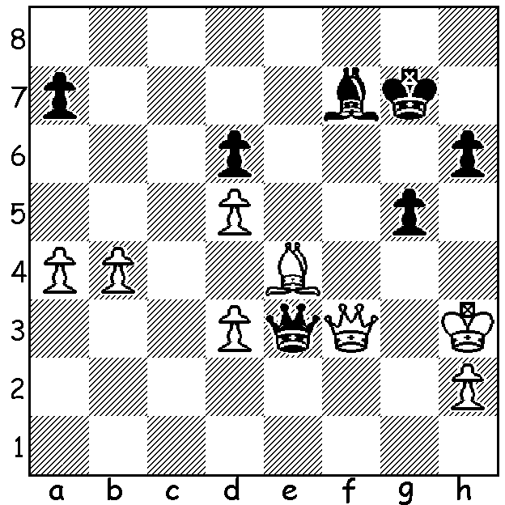

*Bent Larsen* **Bent Larsen vs** *Boris Spassky*

**Boris Spassky 1981**

Black to play and win.

**BORIS SPASSKY IN FRANCE**

While not facing the same punishment as Mark Taimanov who lost 0-6 to Bobby Fischer, Spassky was banned by the Russian chess authorities from flying abroad for two years after his loss of the world title to the American. This may well have encouraged him to leave Russia and he emigrated to France in 1976, becoming a citizen in 1978. He later represented France in three Olympiads, scoring 24.5/41 (+9 =31 -1), having previously played for USSR in seven Olympiads, scoring 69/94 (+45 =48 -1). He continued to achieve success after the Fischer match including winning the 1973 USSR championship with 11.5/17 (ahead of Karpov, Petrosian, Korchnoi, Geller, Keres, Taimanov and Tal among others) and 1983 Linares with 6.5/10 ahead of Anatoly Karpov. He continued to play in Candidates, reaching the final in 1977 before losing to Viktor Korchnoi 10.5-7.5 (+7 =7 -4). Spassky was down 2.5-7.5 before rallying to winning four consecutive games before Korchnoi won the final two games after two draws. Spassky suffered a stroke in 2006 and a second more severe stroke in 2010 which left him paralysed on his left side. He returned to live his last years in Moscow before dying on 27 February this year.

He made significant contributions to Opening Theory in the Marshall Gambit in the Ruy Lopez (1.e4 e5 2.Nf3 Nc6 3.Bb5 a6 4.Ba4 Nf6 5.0-0 Be7 6.Re1 b5 7.Bb3 0-0 8,c3 **d5**), the Leningrad Variation in the Nimzoindian (1.d4 Nf6 2.c4 e6 3.Nc3 Bb4 4.**Bg5**), the Tarrasch Defence in the Queens Gambit (1.d4 d5 2.c4 e6 3.Nc3 **c5**) and the Closed Sicilian (1.e4 c5 2.**Nc3** Nc6/d6 3.**g3**).

Besides being recognised as a great player, Spassky was universally admired as a true gentleman and sportsman, gracious in victory and dignified in defeat, a player who always sought to be on friendly terms with opponents whatever their character and disposition.

**SOLUTION:** 1…g4+! 2.Kxg4 Bh5+! 3.Kxh5 (3.Kg3 Bxf3) 3…Qxg5#