CHESS 26 April 2025 David Ellis [ellisd19@bigpond.com](mailto:ellisd19@bigpond.com) 043979860

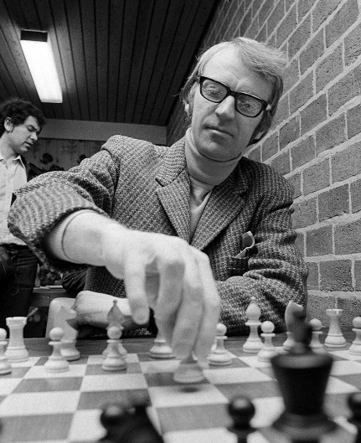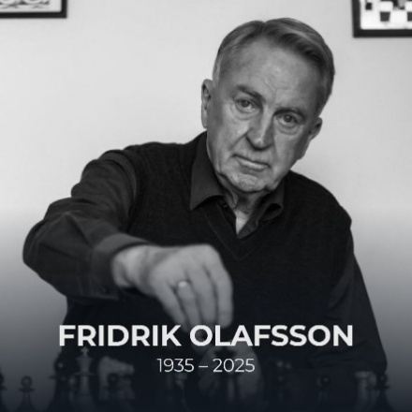  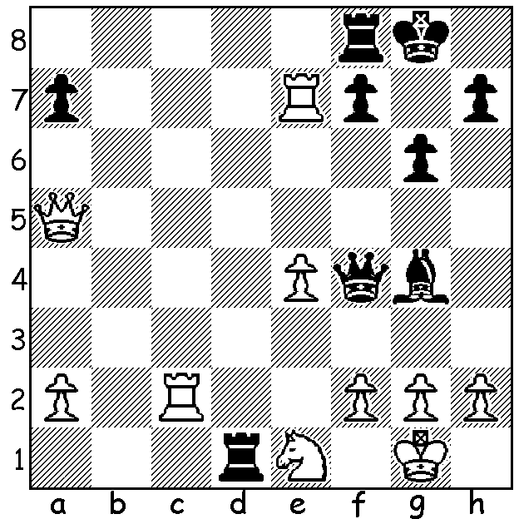

**Mikhail Tal vs Fridrik Olafsson 1975**

Black to play and win. *Olafsson in 1976*

**FRIDRIK OLAFSSON 1935 - 2025**

Only five weeks after the death of former world champion Boris Spassky, another GM of the same era, Fridrik Olafsson, passed away on April 4 in Reykjavik, Iceland, at the age of 90. Olafsson, the first GM from Iceland, learned the game from his father when eight and won his first national title aged 17 (he was Icelandic champion six times in all as well as Scandinavian champion in 1952, the year he was bronze medalist in the world junior championship). He shared first place at the prestigious 1955-56 Hastings tournament, UK, with Viktor Korchnoi. Having arrived in Hastings the day before the tournament, he was at first unable to find accommodation during the busy holiday period and spent a night in a police cell thanks to a kind policeman. Perhaps his greatest tournament success was 1st= with Ljubimir Ljubojevic at the annual Wijk aan Zee tournament (then sponsored by Hoogovens, now by Tata Steel). At one time he was the 13th highest rated player in the world and had multiple wins against Bobby Fischer, Tigran Petrosian and Mikhail Tal, all world champions, and after his win against Anatoly Karpov in 1980 he became one of the members of the elite ‘Chigorin Club’, players who have defeated a reigning world champion but have not themselves become world champion. He represented Iceland eight times in Olympiads and won Board 1 prize in 1962 (+10 =8 -0). He became President of FIDE in 1978, taking over from Max Euwe. He sought to improve commercial sponsorship for the game and relations between the Russia and the rest of the world. He was in charge at the bitter world championship match between Russian Anatoly Karpov and dissident Viktor Korchnoi in 1978. In 1982 he lost the vote for FIDE president to Florencio Campomanes, mainly due to opposition from Russia and its allies. Olafsson’s greatest legacy is the popularity of the game in Iceland which has the highest number of native-born GMs per head of population (currently 13 in a population of under 400,000) with the popularity of the game receiving an initial burst through Olafsson’s work to have the Spassky-Fischer match played in Reyjkavik in 1972.

**SOLUTION:** 1…Qg5! if 2.Qxg5 Rxe1#: if 2.Qb4 Qxe7!