CHESS 3 May 2025 David Ellis [ellisd19@bigpond.com](mailto:ellisd19@bigpond.com) 043979860

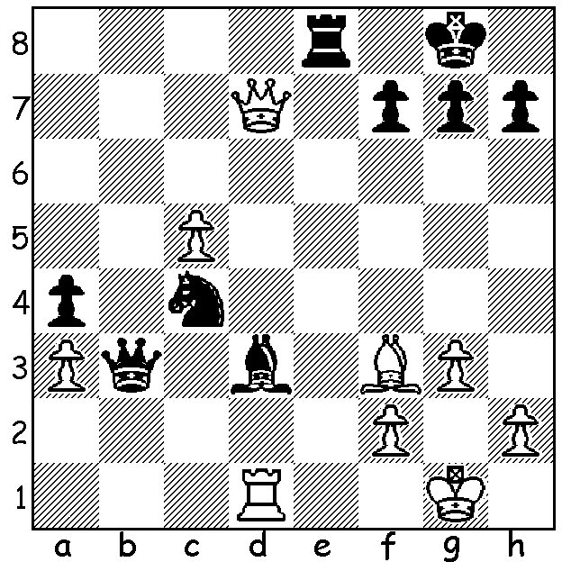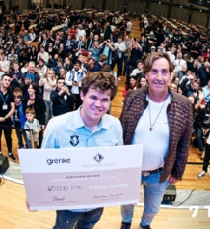

**Wesley So vs Magnus Carlsen 2016:**

with Black’s rook and bishop attacked Magnus with winning cheque at

White expects to recover the piece Grenke event. Also co-sponsor

sacrificed. He is in for a shock Jan Henric Buettner

(Black to play, 5 moves).

**MAGNUS REACHES NEW HEIGHTS**

At the recently completed Grenke chess event Magnus Carlsen completed the star-studded Freestyle Open A with the amazing score of 9/9, defeating seven Grandmaster and one International Master along the way. This is considered the greatest achievement of all time, surpassing Bobby Fischer’s score of 11/11 in the 1963-64 USA Championship with Carlsen’s performance rating of 3191 higher than Fischer’s 3187.

The event, held in Karlstruhe, Germany, between April 17th and 21st, had over 3500 competitors with 297 competing in the Freestyle Open A. The event is named after sponsor German leasing company Grenke AG.

**JU WENJUN DEFENDS WORLD TITLE**

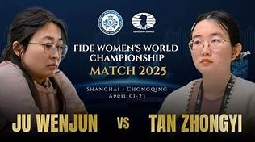Defending champion Ju Wenjun comfortably retained her

title against the winner of the 2024 Womens Candidates

and former champion Tan Zhongyi in the best of 12 game

match played in both Shanghai and Chongqing between

April 13th and 21. Despite falling behind after losing

Game 2, Ju won five of the next seven games to finish 6.5

-2.5. The two Chinese contestants have played each other

in three championship matches with Tan defeating Wu

1.5-0.5 in the 64-player Knockout in 2017 but losing 4.5

-5.5 in a 10-game match in 2018. Ju has now won or

defendedthe title five times, a feat achieved previously by

Vera Menchik, Nona Gaprindashvilli and Maia Chiburdanze.

**BUNBURY OPEN**

The resurrected Bunbury Chess Club is holding a six-round Open on the weekend of 17 & 18 May. The inaugural Open, held last year and won by Tim Hare, had generous prizes over three rating groups among the 19 contestants and it hoped even more will play this year so get your entries in.

**SOLUTION:** 1…Qxd1+!! 2.Bxd1 Re1+ 3. Kg2 Bf1+ 4.Kf3 (4.Kh1 Bh3#) 4…Ne5+ winning the queen. Wonderful coordination of all his pieces by Magnus.