CHESS 10 May 2025 David Ellis [ellisd19@bigpond.com](mailto:ellisd19@bigpond.com) 043979860

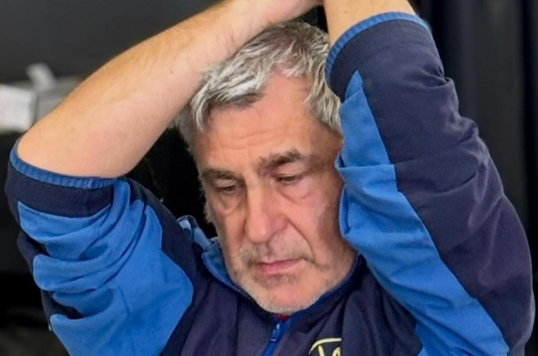

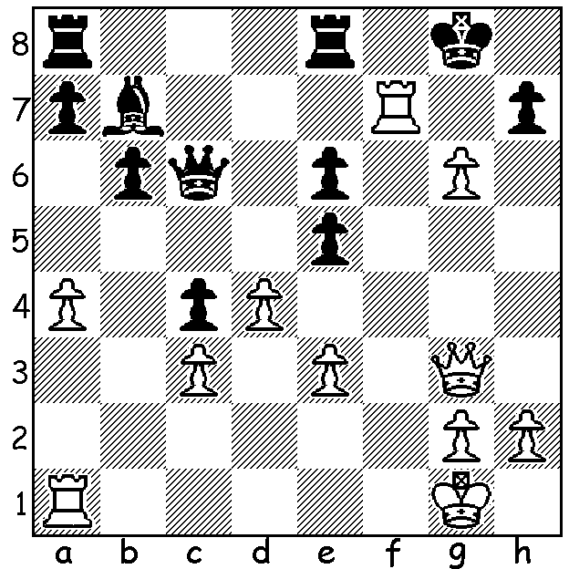

**Vasyl Ivanchuk vs Hao Wang 2012**

a piece down, White to play wins

(move 3 is a !)

**UNBEATEN RUN BY VETERAN**

Ukranian Vasyl Ivanchuk, was born in 1969 and reached his peak in the early to mid-1990s which included victory at the 1991 Linares tournament in Spain where he defeated world champion Garry Kasparov, former champion Anatoly Karpov and future champion Viswanath Anand to come first, unbeaten with 9.5/13. He was ranked world number two player a number of times including 1991 and 1992. His victories and tournament successes continued into this century although he had slipped out of the top 100 in rating. However that drop recently changed for ‘Chucky’ with a non-losing run of 27 games in 19 days in April, picking up 40 rating points to reach 82nd in the May FIDE Ratings. He finished =2nd in the Reykjavik Open with 7.5/10, =1st at Alicante with 7.5/9 and he won the Menorca Open (his first tournament victory since 2019), unbeaten with 8/9. Truly an amazing combination of talent and endurance, especially for a 56-year-old.

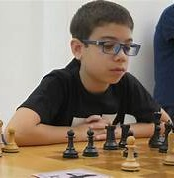 **11-YEAR-OLD’S SETBACK IN GM QUEST**

The Menorca Open was also an opportunity for the

world’s youngest International Master, Argentinian

Faustino Oro, to be the youngest ever to gain a GM.

Norm. He started with 5/6 but, after a loss followed

by two draws, he failed by half a point to achieve the

objective. At present world champion Gukesh

Dommaraju holds the record for youngest to gain a

GM norm at 11 years, 10 months and 24 days in

2018, a record Oro can still better.

**BUNBURY OPEN**

The resurrected Bunbury Chess Club is holding a six-round Open on the weekend of 17 & 18 May. The inaugural Open, held last year and won by Tim Hare, had generous prizes over three rating groups among the 19 contestants and it hoped even more will play this year so get your entries in.

**SOLUTION:** 1.gxh7+!! Kxf7 2.Rf1+ Ke7 3.h8=Q! Rxh8 4.Qg7+ Kd6 5.dxe5+ Kc5 6.Qe7+ Kd5 7.Rd1+ Ke4 8.Rd4+ Kxe3 9.Qg5+ Ke2 10.Qd2#. Alternative Black moves lead to quicker mates. An enjoyable king hunt.