CHESS 24 May 2025 David Ellis [ellisd19@bigpond.com](mailto:ellisd19@bigpond.com) 043979860

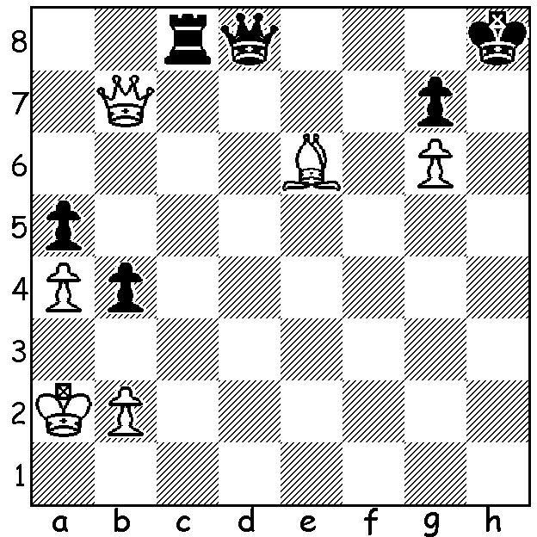

**Minia vs**

**Qavic 1989*:**

faced with mate

and loss of rook

Black gains an

unexpected draw

(3 moves).

.

**US GM IN DOUBLE TROUBLE**

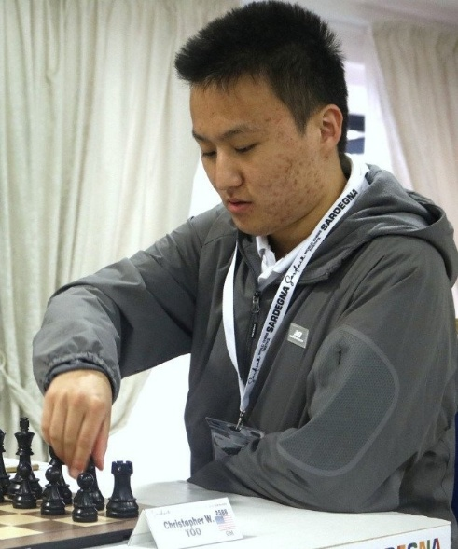Eighteen-year-old **Christopher Yoo** (born 2006) is a very talented young player who in February 2019 became the youngest American to become an International Master (this record has since been beaten by Abhimanyu Mishra, 10 yrs 9 mths 20 days). He became a Grandmaster in 2021 and won the US Junior Championship in 2022 with 7/9. However his chess successes have been over- shadowed in the past few months by behaviour which has

resulted in action by police authorities, the US Chess Federation

and FIDE. Yoo was expelled from last year’s USA Championship

after he was charged as a minor for striking a female video-

grapher following a Round 5 loss to the subsequent winner

Fabiano Caruana. This action led to his being banned from all US

tournaments for one year after the St Louis police charged him

with assault and he was ordered to undergo weekly anger

management therapy. USCF also issued him with a five-year

probation extending to November 2030. The ban did not prevent

his playing abroad and in a recent tournament in Italy, the

Sardinia Chess Festival, he claimed first place, unbeaten with 7.5/9.

However the victory was sullied by another brush with the law

after being accused of inappropriate and unwelcome contact by a

female competitor, including following her through hotel premises,

attempting physical contact and posting an image on social media implying a romantic relationship. The FIDE Ethics and Disciplinary Commission was quick to act, imposing a sixty-day temporary suspension on Yoo. A police investigation is ongoing but Yoo has already had scholarship and grants withdrawn in the USA.

**SOLUTION:** The main threat is Qh1+ mating so Black prevents this with 1…Rc6!! attacking the bishop and after 2.Qxc6 Black forks both White’s pieces with 2…Qd5! with a stalemate after 3.Q/Bxd5 b3+! whether or not White captures the pawn.

* Names cannot be verified and it is possibly a game between two chess engines.