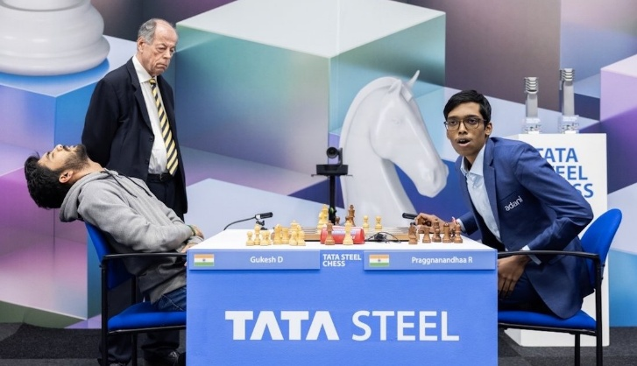 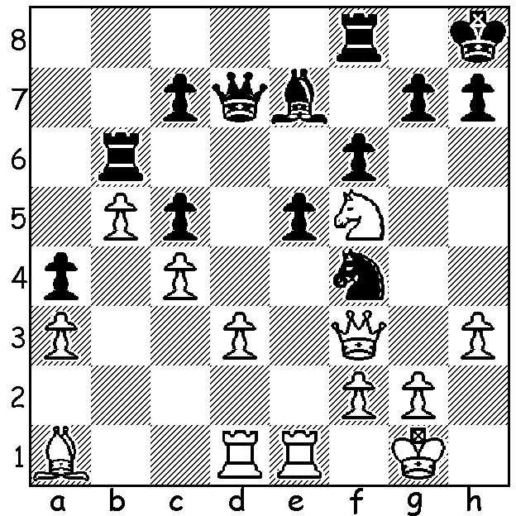

**Praggnanandhaa vs**

**Alexander Krastev 2015**

White to play and win

(3 moves)

**SECOND 2025 SUCCESS FOR YOUNG INDIAN**

After his success in winning the 2025 Tata Steel Tournament in February when he defeated world champion Gukesh Dommaraju 2-1 in play-off, nineteen-year-old Praggnanandhaa Rameshbabu secured a second major tournament success this year, winning the Grand Chess Tour Tournament in Bucharest, again in a play-off. Pragg led going into the final round but a draw against Levon Aronian allowed the two French contestants, Alireza Firouzja and Maxime Vachier Lagrave with wins against Daniel Deac and Jan-Krzysztof Duda respectively to ensure the play-off. After Pragg vs Firouzja and MVL vs Firouzja were drawn, Pragg defeated MVL to take the title. Pragg has now reached world number 7 in rating, the third Indian after Gukesh (3rd) and Arjun Erigaisi (4th).

**BUNBURY OPEN**

The Bunbury Open played at the Manea Senior College, 17th & 18 May, attracted 22 players from Perth and the South West. Winner was young Irish doctor, Alice O’Gorman, originally from Dunlin, who has been in Perth less than a year. Winning her first five games, she was held to a draw by Derek Roebuck in the final round to finish on 5.5/6. Second was Michael Gunawan with 4.5/6. Elvan Rrasa (3.5/6) won the 1st Under 1600 rating prize, Aidan Malik and Andrew Fyfe (3/6) shared 1st in the Under 1300 and Ugyen and Callum Sullivan (2/6) shared 1st for unrated players. Thanks to Michael Molenaar and all his helpers for putting on a enjoyable and well-run tournament. The club meets regularly on Thursday at the college and welcomes new players of any standard.

**SOLUTION:** 1.Nxe7 Qxe7 2.Qxf4! exf4 3.Rxe7.