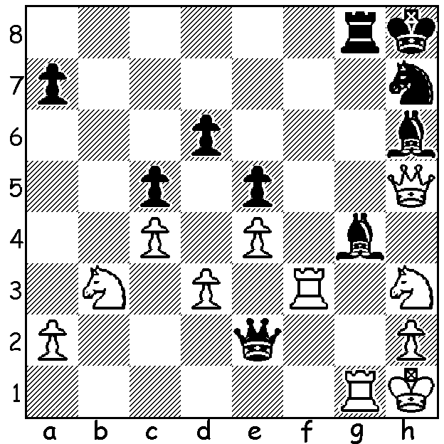

**Hikaru Nakamura** *Nakamura Carlsen*

**vs Magnus Carlsen Yi Liu**

**(**2025 Chess.com Classic):

Find the winning move for

White.

**MAGNUS WINS MAY KNOCK-OUT**

World number 1, Magnus Carlsen was winner once more in the second online 2025 Chess.com Classic, defeating Maxine Vachier-Lagrave 2.5-0.5. Sixteen players competed in a 10 minute (no increment) blitz knock-out with players who lost in one round able to compete in a

losers group (MLV lost in the winners group in Rd 2 but won all his matches in the losers group to reach the final). With wins against Jan-Krzsztof Duda 2.5-1.5, MVK 3-0, Nodirbek Abdusattorov 3-1, Hikaru Nakamura 3-1 and MVL 2.5-0.5, Carlsen went through the event without a loss (just one hiccough) in his eighteen games, earning US$25.000.

The tournament was a qualifying event for the Esports World Cup with the top six players together with the top six from the earlier 2025 Chess.com Classic qualifying. A further four places are reserved for the leading four players from the 256 player Dallas 256 Swiss. The Chess,com Classic qualifiers are Carlsen, Nakamura, MVL, Abdussatorov, Vladimir Fedoseev, Duda, Fabiano Caruana, Areza Firouzja, Ian Nepomniachtchi, Arjun Ergasi, Vladislav Artemiev and Wei Yi.

The Esports World Cup, a multi-game event, will be held in Riyadh, Saudi Arabia, from July 8 to 24 August with a prize pool of a staggering US$70,450,000 with Chess being involved for the first time. The Chess event will have a prize pool of $1500,000 with opportunity to advance to more lucrative challenges.

**SOLUTION:** Amazingly Nakamura, who is the second best in the world in rapid forms of chess, resigned. Commentators were astounded when he had 1.Rfg3!! winning; if 1…Bxh5 2.Rxg8#; if 1…Qxf3+ 2.Rxf3 Bxh5 3.Rxg8+ Kxg8 or 1…Rg5 2.Qe8+ Rg8 3.Qf7 Rg7 4.Qf2 and White

remains the exchange up.