CHESS 12 July 2025 David Ellis [ellisd19@bigpond.com](mailto:ellisd19@bigpond.com) 043979860

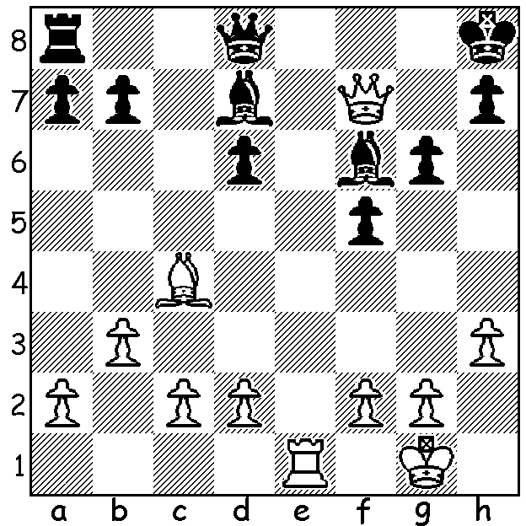

**Rashid Neshmetdinov**

**vs Yuri Kotkov 1957** *.*

White mates in 2 moves.

**RELIGIONS’ ATTACK ON CHESS**

After taking over Afghanistan for the second time in 2021, the Taliban again banned Chess due to concerns over gambling as well as it being a distraction from religious duties. For many centuries Chess was under suspicion or forbidden by many religions, including Islam, Judaism, Catholic and Orthodox churches and Puritans. Here are a few examples:

**ISLAM** – in 642 Muhammad’s son-in-law Ali ibn Abi Talib disapproved of chess because of the ‘graven images’(carved figures of pieces).

In 1005 Chess was banned in Egypt with all sets ordered to be destroyed.

**ROMAN CATHOLICISM** – in most cases the injunctions against Chess were directed at the clergy. As early as 1061 Cardinal Damiani forbade the clergy from playing and complained to the Pope that it was interfering with their duties as priests.

In 1195 the Knights Templar, who were a military order established to protect pilgrims, were forbidden from playing.

In the 13th century in France Chess was first forbidden for the clergy and others in religious orders before Louis IX issued a decree banning Chess, calling it ‘a useless and boring game’.

In England in 1291 the Archbishop of Canterbury threatened to put priests who played chess on a diet of bread and water.

**ORTHODOX CHURCHES** – in 1093 the Eastern Orthodox Church condemned and banned Chess. In 1551 leading Russian clerics banned Chess claiming it was ‘witchcraft and heresy’,

**JUDAISM** – In 1195 Rabbi Maimonides included Chess among forbidden games but only if it involved gambling (a popular form of Chess in earlier times involved rolling dice to determine which piece should move, hence its inclusion as gambling).

However we have the example of Ruy Lopez (c1530 - c1580), an early writer and pioneer of Chess in Europe who was a a Spanish priest, and St Teresa of Avila who was proclaimed patroness of Chess in Spain in the 16th century.

**SOLUTION**: 1.Re8+! if 1…Bxe8 2.Qf/g8 & if 1…Qxe8 2.Qxf6#, Themes deflection & Interference, This miniature was a Ruy Lopez, Berlin Defence (3,,,Nf6).