CHESS 16 August 2025 David Ellis ellisd19@bigpond.com 0439798607

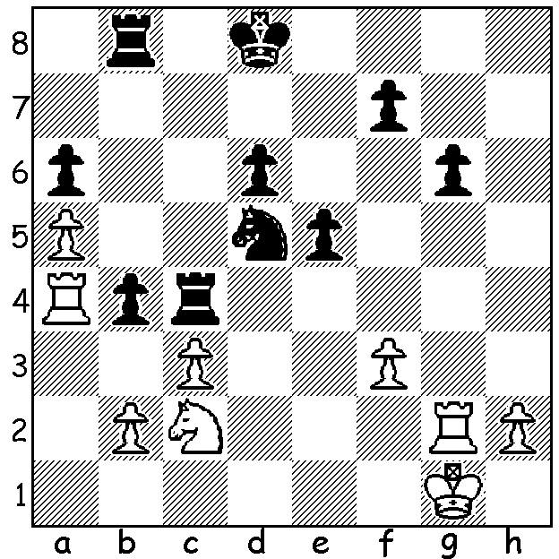

Arjun Erigaisi vs
Ian Nepomniachtchi
(2025 World Esports)
Can you calculate an
8 move win for Black?

CHESS PLAYED FOR FIRST TIME IN ESPORTS
For the first time ever chess was included in the Esports World Cup Federation competitions, played in Riyadh, Saudi Arabia, July 29 to August 1. Sixteen of the world’s top players competed in four groups of four (six games each) before the tournament went on to a knockout. The games were played with a rapidplay time control of 10 minutes with NO increments. In the knockout stage matches consisted of four games for the Quarterfinals, six for the Semifinals with an Armageddon game to decide if matches finished level. If involved in an Armageddon game, players made secret bids of under ten minutes to be Black (White retains his full time quota) and go through if the
Armageddon game is drawn or won. The four semifinalists were Arjun Erigaisi (India) ,Alireza Firouzja (France), Magnus Carlsen (Norway) and Hikaru Nakamaru (USA). The semifinals had the most anticipated match of the competition, between the top two players of quick chess in Carlsen and Nakamura with the match level at 3-3 before going to Armageddon. Nakamura bid 6min 12 sec but lost the game leaving Carlsen to face Firouzja in the final. The final consisted of a tennis-style match of three sets of four games with Carlsen winning 3-1, 3-1, while Nakamura defeated Erigaisi 3.5-2.5 for third place. The prize fund was $1.5 million with Carlsen taking home $350,000.

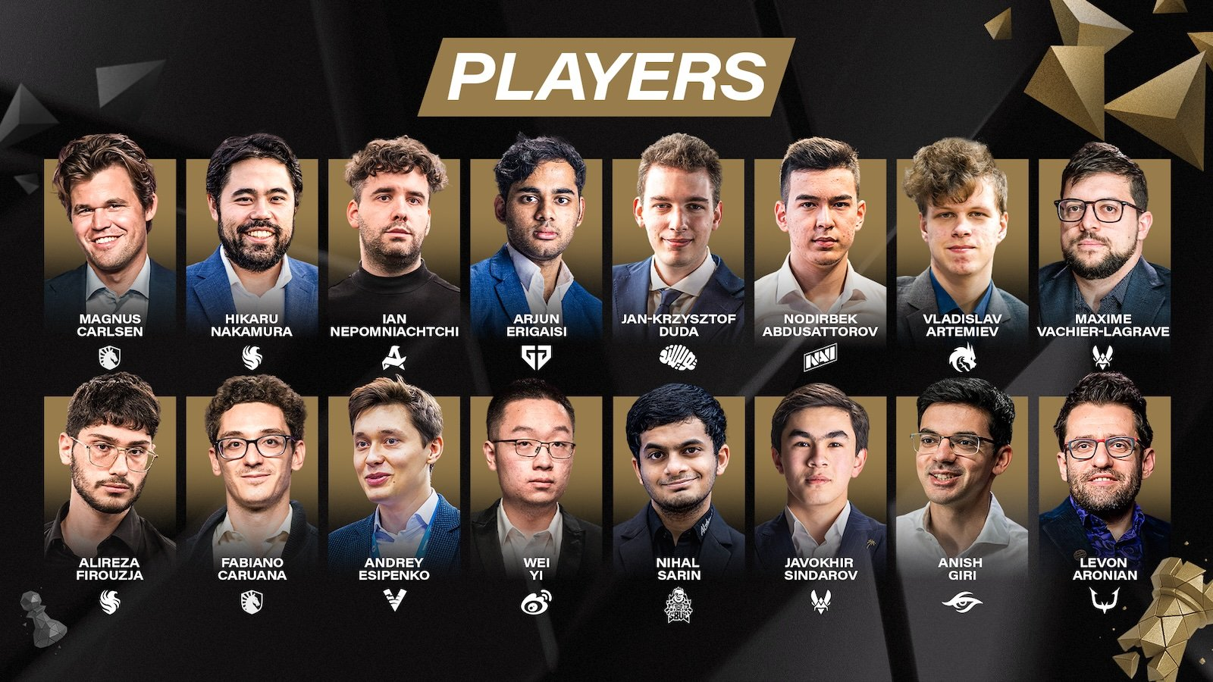

SOUTH WEST OPEN
The South West Open will be played in Margaret River on Sat 13 & Sun 14 September with an
Allegro tournament on Sat and the regular weekend 60 minute event to be played over the two days. See cawa.org.au for details.

SOLUTION: 1…bxc!! 2.Rxc4 cxb 3.Na3 b1=Q 4.Nxb1 Rxb1+ 5.Kf2 Rb2+! 6.Kg1 Rxg2 7.Kxg2 Ne3+ resigns (8…Nxe4), Despite winning this game Nepo lost the quarterfinal 1.5-2.5.

