CHESS 23 August 2025 David Ellis ellisd19@bigpond.com 043979860
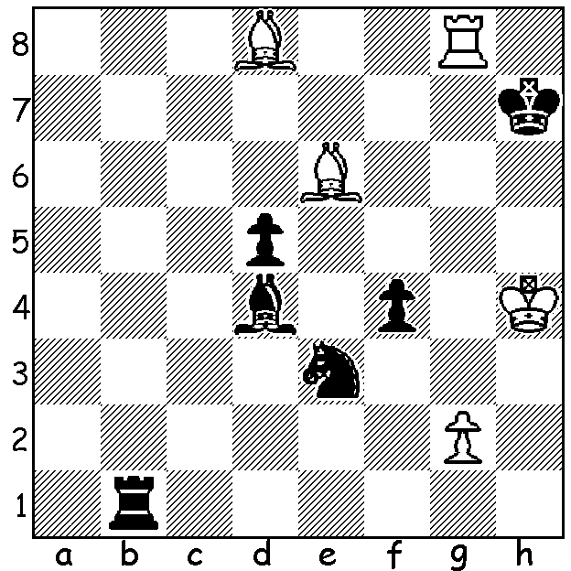

Vidit Gujrathi vs
Karthikeyan Murali
(Chennai Masters 2025):
Black to play wins a piece
(5 moves).


NINTH BRITISH CHAMPIONSHIP TO ADAMS

This month in Liverpool Michael Adams won his
ninth British Championship. He finished with 7/9
but needed a rapidplay playoff to take the title with
his score equalled by Peter Roberson and Stuart
Conquest. Adams first won the title in 1989 and
Now is only one win away from the ten championship
titles of Jonathan Penrose, won between 1958 and 1969.

Ten-year-old Bodhana Sivanandan scored 5/9 to

gain her final WIM (Womens International Master)
norm, the youngest ever and she also became the
youngest girl to defeat a Grandmaster with victory
over Peter Wells in the final round.

The field for the Championship had one hundred
players while altogether over one thousand competed
in the various competitions.


YOUNG GERMAN IS NOW A TOP 10 PLAYER
Twenty-year-old Vincet Keymer was a runaway victor
in the recent ten-player Chennai Masters, scoring 7/9,
unbeaten and two points ahead of Anish Giri (Netherlands),
Arjun Erigaisi, and Karthikeyan Murali (both Indian). Giri
was also unbeaten after gaining his only win in the final
round. Keymer’s success pushes him up to 10th in world
ratings.

COMING WA TOURNAMENTS
South West Open 13-14 September in Margaret River.
Perth International Open 26 – 29 September at Manning Hall Community Centre.
Check cawa.org.au for details.

SOLUTION: 1…f3! (threat 2…f2 or fxg) 2.gxf Rh1+ 3.Kg5 Rg1+ 4.Kh5 Rxg8 5.Bxg8 Kxg8 & wins (themes – promotion, deflection, skewer). Karthikeyan, a two-times Indian champion who only played in the Masters after the withdrawal of Vladimir Fedoseev, finished =2^{nd..}

