CHESS 30 August 2025 David Ellis ellisd19@bigpond.com 043979860


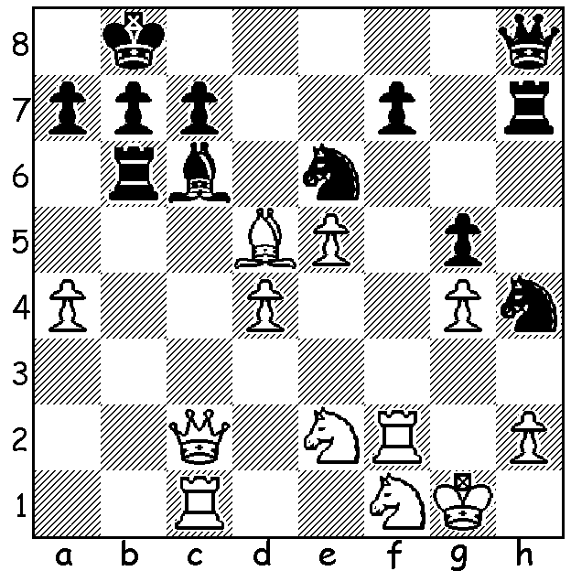

Levon Aronian vs Aronian, winner in St Louis 2025
Ibragim Khamrakulov 1993
Two deflections give
White a win:

VETERAN WINS IN ST LOUIS
Born in 1982 in Armenia, Levon Aronian moved to USA in 2021. He became a GM aged 17, is a former world champion in 960Chess, Rapid and Blitz and was ranked second in the world in Classical Chess in 2014. He led Armenia to gold medals in 2006, 2008 and 2012 and he was named 2005 Armenian Sportsman of the Year. Earlier this month, the oldest player in the tournament, he rolled back the years to win the ten-player, St Louis Rapid & Blitz title, with 24.5/36 finishing three points ahead of runner-up Fabiano Caruana with Maxime Vachier-Lagrave third. World champion Gukesh Dommaraju finished a disappointing =6th. Caruana, with 14/18 had led by a point in the Rapid (2pts for win, 1pt for draw) but could only score 7.5/18 in the Blitz.

PROGRESS OF YOUNG TURK

Yagiz Kaan Erdogmus now holds the record of
Highest-rated Under 13, Highest-rated Under 14,
Highest-rated Under 15 as well as the Youngest-
ever 2600+ rating and second youngest to enter
the world’s top 100 (behind Judit Polgar). He was
introduced to chess by his kindergarten teacher and
started playing competitively aged six years. He is
the fourth youngest ever to become a GM
(Grandmaster) behind Abhimanyu Mishra (USA),
Sergey Karjakin (Russia) and Gukesh (India).

SOLUTION: 1.Bxe6 (if 1…fxe6 2.Qxh7! & if 2…Qxh7 3.Rf8 mates. Played when Aronian
was 10 or 11.

