CHESS 6 September 2025 David Ellis ellisd19@bigpond.com 043979860


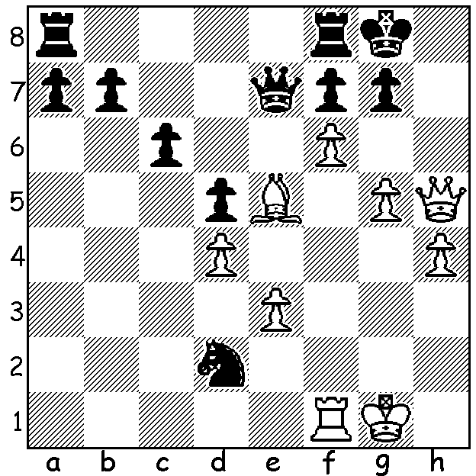

Levon Aronian Sinquefield Cup winner Wesley So
vs Wesley So
(Sinquefield Cup 2025)
Can Black avoid loss?

BITTER SWEET VICTORY TO WESLEY
The Sinquefield Cup, a ten-player Classic tournament played between 18 and 28 August at the St Louis Chess Club, was a particularly important event this year, not only because of the strength of the field with only one player rated below 2700, but because it was the last chance for players to cement one of four places in the Grand Chess Tour Finals to be held later this month at Sao Paulo, Brazil. The Grand Chess Tour (GCT) is a series of five tournaments, two Classic and three Rapid/Blitz events with the nine main competitors playing the two Classic and two of the Rapid/Blitz tournaments. Before Sinquefield the leading GCT players were Maxime Vachier-Lagrave (28 pts), Levon Aronian (25.5), Alireza Firouzja (22.5), Fabiano Caruana (20.5) Praggnanandhaa Rameshbabu (20) and Wesley So (19.5). Winner of the Sinquefield was Wesley So, who had previously won the event in 2016. After six successive draws So won two and drew one of his final three games to catch Pragg and Caruana with all three finishing on 5.5/9. In the Rapid play-off So defeated Pragg and drew with Caruana while Pragg defeated Caruana. With all three gaining 10 GCT points the GCT qualifiers were MVL (33 pts), Caruana and Aronian (30.5) and Pragg (30) leaving So missing out by a half point.

SOLUTION: 1…Qxe5!! removing a vital piece in White’s attack. After 2.dxe5 Nxf1 leaves Black with a considerable material advantage, forcing White to take a draw with 3.fxg Kxg7 4.Qh6+ Kg8 5.g6 fxg 6.Qxg6+ Kh8 7.Qh6+ with a perpetual check.

