CHESS 20 September 2025 David Ellis 0439798607 ellisd19@bigpond.com
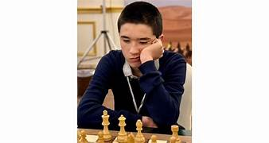
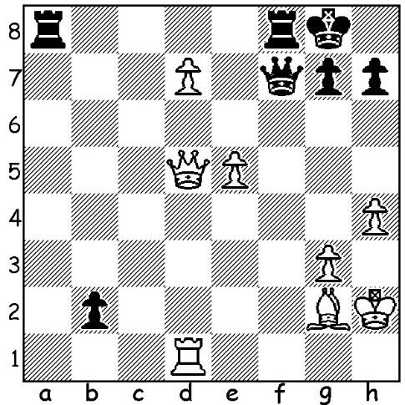
Andy Woodward vs Parham Maghsoodloo Andy Woodward (Grand Swiss 2025): White brings off a spectacular win (5 moves).
GIRI & BLUEBAUM QUALIFY FOR CANDIDATES

The 2025 Grand Swiss, with 116 competitor, played in Uzbekistan, finished on Monday with a decisive win to Anish Giri (Netherlands) after defeating Hans Niemann (USA) in the final round. Giri was the only player among the five leaders to win to finish on 8/11. Just behind on 7.5 were Matthias Bluebaum (Germany), Alireza Firouzja (France) and Vincent Keymer (Germany) with Bluebaum awarded second place on tie-break (average of opponents’ scores).
Both Giri (pictured) and Bluebaum now qualify for next year’s Candidates tournament to find a challenger for world champion Gukesh Dommaraju (India). Gukesh had a poor tournament, finishing with 6/11 which included three losses on the trot. Parham Maghsoodloo, who led after six rounds with 5/6, was only able to pick up one point in his last five games. Two young Americans finished on 7/11, 15-year-old Andy Woodward, who defeated Maghsoodloo in Rd 7 (see diagram) to start the Iranian’s slide, and Abhimanya Mishra, 16, who has now played 67 successive Classic games without loss. A number of former top players competed – Alexei Shirov 6.5, Vassily Ivanchuk 5.5, Ruslan Ponomariov 5.5 and Boris Gelfand 4.5.
SOLUTION: 1.Qxa8!! resigns (1…Rxa8 2.d8=Q+ Rxd8 3.Rxd8+ Qf8 4.Bd5+! Kh8 5.Rxf8#)

