CHESS 27 September 2025 David Ellis 0439798607 ellisd19@bigpond.com

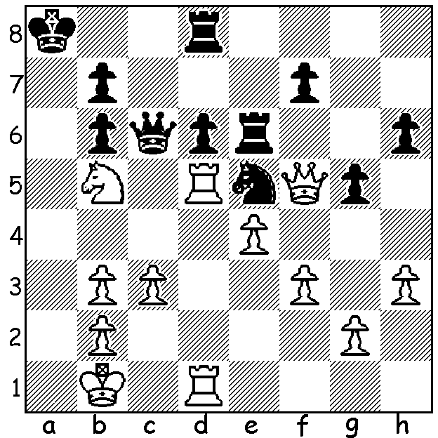

Vaishali Rameshbabu vs Carissa Yip
(FIDE Womens World Cup 2025)
White to play and win (4 moves).

WOMENS GRAND SWISS
While 116 men were competing in the2025 Grand Swiss in Uzbekistan, 56 female players were competing in the third Womens Grand Swiss (previously held in 2021 & 2023), with a similar objective, to gain one of the two available places to the Womens Candidates Tournament next year to find a challenger to Ju Wenjun. After 11 rounds two players, Indian Vaishali Rameshbabu, sister of Pragg and winner in 2023, and Russian Kateryna Lagno, finished on 8/11 with both qualifying for the Candidates and the Indian awarded first place on tiebreak. Third with 7.5/11 was Bibisara Assaubayev (Kazakhstan), Womens Blitz champion 2021 & 2022, who was the only player to defeat Vaishali.
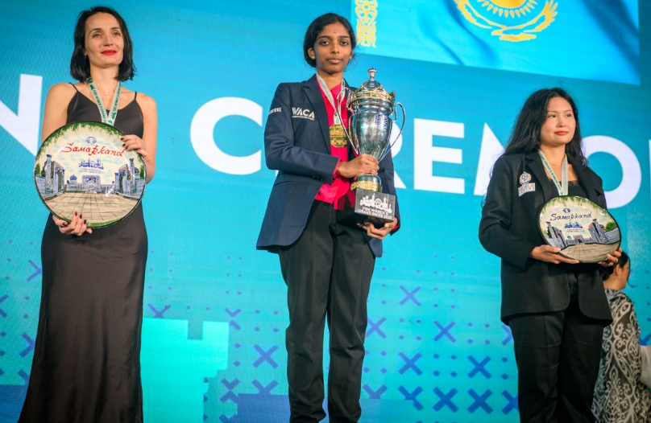
Lagno, Vaishali and Assaubayev

SOUTH WEST OPEN
Last weekend in Margaret River was a chance to see Grandmaster Temur Kuybokarov play before he heads off next month to play in the Chess World Cup after qualifying by winning the 2025 Oceania Zonal. As expected Temur won the Open with 6/6 with Tim Hare and Willis Lo from ACT runners-up with 4.5/6 (26 players). Rating Prizes: Under 1800 Ricky Huang (4/6), Under 1600 John Pince (3.5). The one-day Under 1500 Allegro ended with three players sharing top place on 7/9, Lachlan Walker, Joshua Bartlett and Max Beard (20 players).

SOLUTION: 1.Rxe5+! resigns (1…Rxe5 2.Qxe5! dxe5 3.Rxd8+ & mates)

