CHESS 11 October 2025 David Ellis ellisd19@bigpond.com 043979860


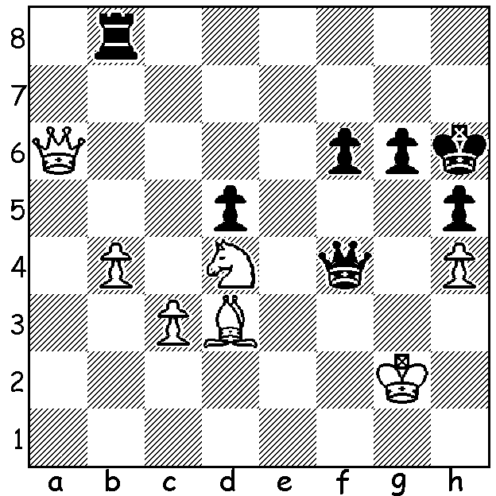

Magnus Carlsen vs Wedding of Magnus & Ella Victoria
Maxine Vachier-Lagrave 2006
White to play and win (5 moves)

A GOOD YEAR FOR MAGNUS
In the latest FIDE ratings Magnus Carlsen heads the list in all three categories, Standard or Classic, Rapid and Blitz, 2839, 2808 & 2881 respectively. This is now 171 successive months Magnus has been top in Classic, well over 14 years. It has been a great year for him: married in January to Ella Victoria Malone, winner of seven tournaments and becoming a father last month to a boy.

FAB WINS GRAND CHESS TOUR
The 2025 Grand Chess Tour consisted of five
Rapid & Blitz tournaments with the top four

players qualifying for the finals, played in Sao
Paulo, Brazi, which concluded a week ago. The
four contestants faced each other in KO matches
of 2 Classic, 2 Rapid & 4 Blitz games (6 pts for
wins in Classic, 4 for Rapid, 2 for Blitz). In the
semi-final Fabiano Caruana defeated Levon
Aronian in a close match 15-13 and Maxine
Vachiere-Lagrave defeated Praggnanandhaa
17-11. In the play-off for third Aronian defeated
Pragg 20-8 while in the final the match went
down to the wire with MVL missing a win in the MVL Caruana
final Blitz game that would have evened the (Grand Chess Tour Final)
score 14-14. Instead, with a final draw, Caruana
won the match and title 15-13.

SOLUTION: 1.Nf5+! (interruption sacrifice) 1…gxf5 2.Qxf6+ Kh7 3.Bxf5+ Kg8 4.Be6+ wins the queen; if 1…Kh7 2.Qa7+ / 3.Qg7#.

