CHESS 18 October 2025 David Ellis ellisd19@bigpond.com 043979860

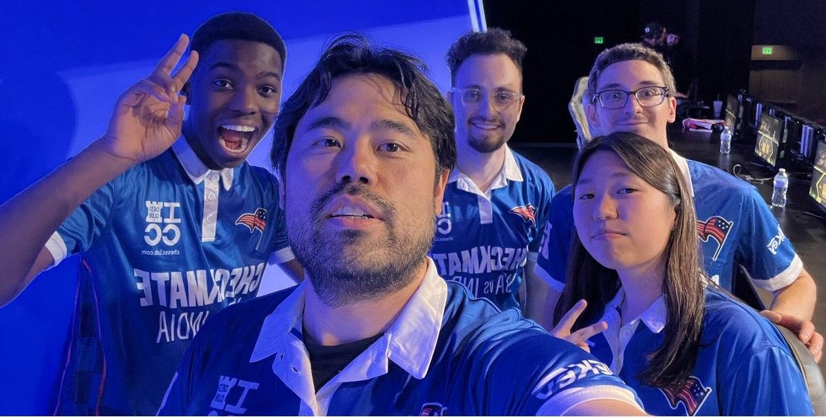
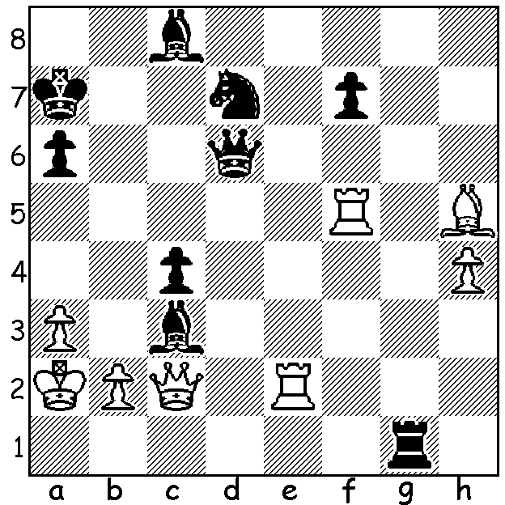

Gennadij Sagalchik vs
Hikaru Nakamura 2003
Black wins quickly.

CHESS AS A SPORTING SPECTACLE
On October 4 the Esports Arena in Arlington, Texas, with a capacity of 2,500, was packed to witness an international
chess match on 5 Boards between USA and India, an experiment to see if chess could appeal to the masses.

A press release stated: ’this is more than just a match between two nations, it’s an experiment to see how chess can be
packaged for live audiences and mainstream sports fans: fast time limits, … an atmosphere closer to NBA or a boxing night’.
USA had White in all boards (India to be White on return match in India) with the games played one after the other with a
time limit of 10 minutes per player with a one second increment when a player had less than one minute remaining.
Each team had a distinctive uniform and each player would make their way through the crowd which was encouraged to
clap and cheer (but not to shout out move suggestions).

The result was an emphatic victory to USA 5-0:
Bd 1. GM Fabiano Caruana defeated GM Arjun Erigaisi; Bd 2 (Rising Stars) IM Tari Adwumi def IM Ethan Vaz;
Bd 3 (Female) IM Carrissa Yip def GM Divya Deshmukh, Bd 4 (Influencer) IM Levy Rozman def IM Sagar Shah;
Bd 5 GM Hikaru Nakamura def GM Gukesh Dommaraju.

The moment Nakamura clinched the clean sweep for USA, he picked up his opponent’s king and threw it into the cheering crowd.
Nakamura received some media criticism for this action but he explained that it was the type of flamboyant gesture encouraged
by the organisers.

SOLUTION: 1… Qxa3+!! 2.bxa3 or Kxa3 Ra1#.

