CHESS 25 October 2025 David Ellis ellisd19@bigpond.com 043979860


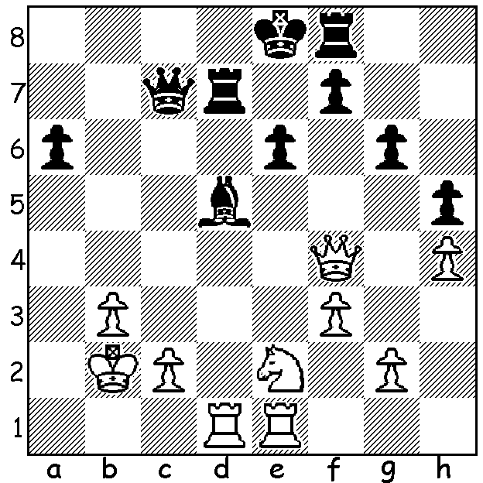

Garry Kasparov vs
Vladimir Kramnik 1999 Kasparov vs Anand 2025
White to play and win

2025 EUROPEAN TEAM CHAMPIONSHIPS
Ukraine was the most successful country in the 2025 European Championships (played 4-15 October in Georgia) winning the Open (40 teams) and
coming second in the Women’s (37 teams). In the Open Azerbaijan was second and Serbia third while Poland won the Women’s with Germany third.
Ukraine’s Igor Kovalenko won gold on Board 4 with his 6.5/8 being the best percentage of any player. What was remarkable about his performance
was that he left his position in the trenches where he acted as a radio operator to compete before returning to the war. He was awarded a decoration
for courage by President Zelensky in 2023. A September 2024 report stated that 21 of leading Ukranian players had been killed in the conflict.



The two sides of Igor Kovalenko, as chess player and as soldier.

BATTLE OF PAST GREATS
Earlier this month past world champions, Garry Kasparov (champion 1985-2000) and Vishy Anand (2007-2013), recently competed in a 12-game
Freestyle (Fischer Random, chess960) chess match at the St Louis Chess Club called the 2025 Clutch Chess, the Legends.
Played over three days with 6 Rapid and 6 Blitz games Kasparov won 13-11 although Anand had been considered favourite being younger at 55
and still active while Kasparov is 62 and retired.

2025 CHESS WORLD CUP
The 2025 Chess World Cup, a knock-out competition with 206 players, begins on October 30 in Goa. WA’s Temur Kuybokarov is drawn against
Jan Subeli (Slovenia). Temur is 25 with a 2535 rating while Subeli is 21 and rated 2545.
The winner next faces Rameshbabu Praggnanandhaa, rated 2771 and currently 5th in world ratings.

SOLUTION: 1.Rxd5! exd5 2.Nd4+ Kd8 (2…Re7 3.Qxc7) 3.Ne6+! winning king or queen:
if 1…Qxf4 2.Nxf4 and White has won the bishop.

