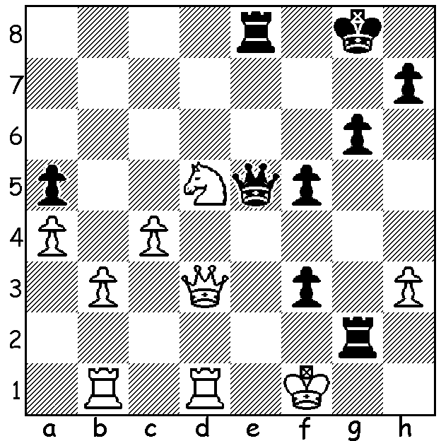




Vladimir Mezentsev vs Daniel Naroditsky
(pictured) 2008: Black wins quickly.

CHAMPIONS SUCCESSFUL DEFENCE

The 2025 USA Championship and the 2025 USA Womens Championship (both 11 round round-robins), played at the St Louis Chess Club from October 12 to 25, were both won by the defending champions. Fabiano Caruana
went almost neck-and-neck with Wesley So through-
out the tournament, taking a half point lead into the
final round. His draw against Levon Aronian in the
final round left So with a chance to join him on 8/11.
However, like the other five Rd 11 games, So’s game
ended in a draw meaning Caruana was US champion
for the fourth year in a row (he also won in 2016).
Carissa Yip, aged 22, began her defence of the
women’s title with her only loss, against Atousa
Pourkashiyan, but stormed home scorin g6.5/7 points
in Rounds 5 to 11 and finishing on 8/11. This was
Yip’s third title success in succession (she also won
in 2021). Atousa Pourkashiyan, who is Hikaru
Nakamura’s wife, competed while seven months pregnant but her win against Yip was her only victory and she finished last with only two points. Pushing Yip hard was runner-up Anna Sargsyan (7.5/11), who recently moved to USA from Armenia.

DEATH OF A LEADING INFLUENCER
US GM Daniel Naroditsky, aged 29, a popular chess streamer, author, teacher and commentator, was found dead at his home in North Carolina on October 19. His death is thought to be a possible suicide or overdose. He had been accused by former world champion Vladimir Kramnik of cheating by using a chess engine during online games. Kramnik has been condemned for his accusations by leading players and statements of his have been referred to FIDE Ethics and Disciplinary Commission. Naroditsky had played hundreds of online games with Carlsen and defeated Caruana in the 2021 US Championship. The 24 October edition of The West Australian contained an almost full page on the tragedy

SOLUTION: 1…Rg1+! 2.Kxg1 Qg3+ 3.Kf1/h1

