CHESS December 20, 2025 David E;llis 04529798607 ellisd19@bigpond.com

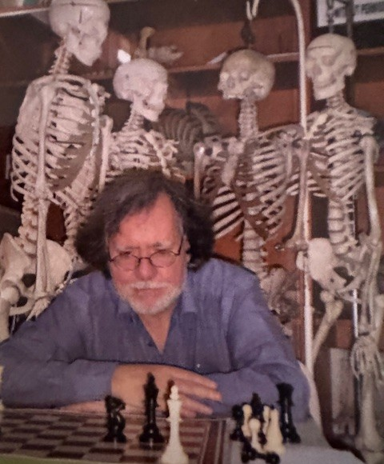
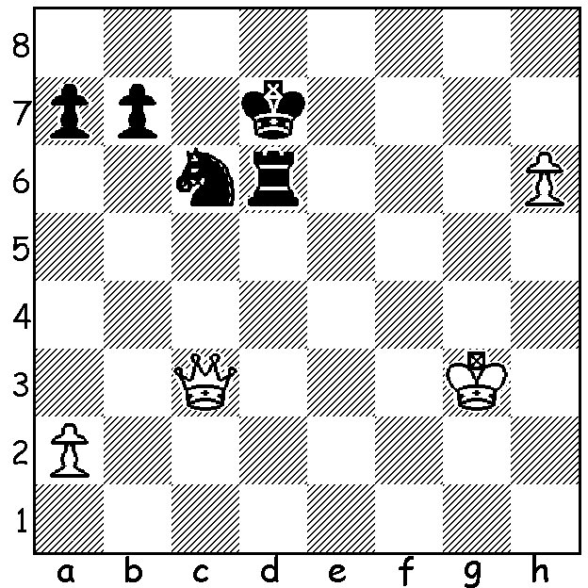
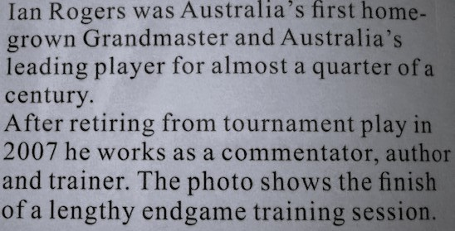
Elisabeta Polihroniade
vs Ian Rogers
(Australian Open 1987):
can Black draw?

HOW’S YOUR ENDGAME PLAY?
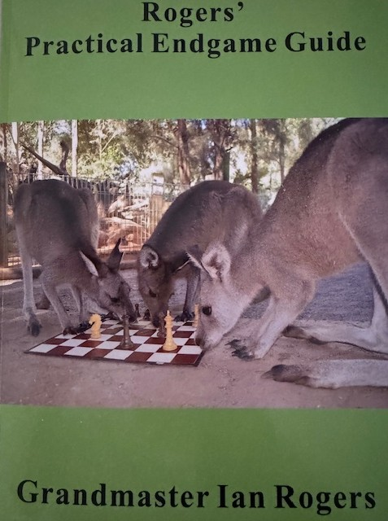
How often do you remember the opening moves, outplay your opponent in the middle game but fail to finish him off in the ending or alternatively get into an inferior ending and lose before finding you had hidden resources that would have drawn? There are many books on the endgame to help improve your play, some general such as Reuben Fine’s ‘Basic
Chess Endings’, first printed in 1941, and some specialised, such
as rook or queen endings. I recently received a newly published
book by Australia’s most famous player, GM Ian Rogers, entitled ‘
Rogers’ Practical Endgame Guide’. It does not claim to be a
comprehensive treatise on endgames but instead concentrates in
Part I on such topics as Pawnless Endgames, Rook Endings,
Queen Endings, Opposite Coloured Bishops and Injustice Patterns.
I found the chapter on Injustice Patterns particularly interesting
revealing positions in which one side has a considerable material
advantage, for example, a piece up, has rook and pawn vs bishop
or knight, or queen and pawn(s) vs rook and pawn(s), but is unable
to win. Part II is called Practical Play and covers such themes as
pawn endings including breakthroughs involving pawn sacrifices,
Saving Bad Positions which includes setting traps, Winning Equal
Positions and finally Technique in which he illustrates two particular maxims, work out how to place your pieces on their ideal squares and kill counterplay. Throughout the book we see many examples from GM Rogers’ long and rich chess career both in Australia and overseas. The 164-page book, is well set out with easy-to-read print and notations in heavy print and I can certainly recommend its purchase which will not only improve your endgame play but be a fascinating read.
It can be purchased for $35 + $10 postage from gmianrogers@gmail.com or from chessaustralia.com

SOLUTION: White’s last move was 1.h6 setting a trap but after 1…Rxh6!! 2.Qg7+ Ne7! and if 3.Qxh6 the trapper is trapped losing to 3…Nf5+. White played 3.Qd4+ Rd6 4.Qxa7 but was unable to win. This was one example from Rogers’ book.

