CHESS December 27, 2025 David E;llis 04529798607 ellisd19@bigpond.com

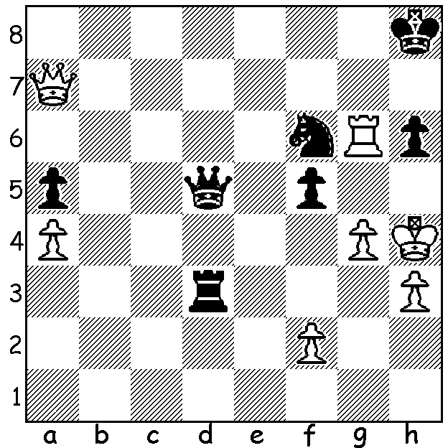

Stephen Boyd vs
Torbjorn Glimbrant 1992:
can Black save the game?

The AUSTRALIAN SCHOOLS TEAM CHAMPIONSHIPS were held earlier this month at the Glen Waverley Secondary College, Victoria, with WA sending teams for all four groups. WA team results: Secondary Open – Rossmoyne S H S 3rd (winner Anglican Church Grammar, Qld) with Barath Harirajesh winning the Best Board 4 prize; Secondary Girls – Presbyterian Ladies College 6th (winner Brisbane S H S); Primary Open – Highgate Primary 5th (winner Anglican Church Grammar, Qld); Primary Girls – Booragoon Primary 3rd (winner Glendal Primary, Vic). Well done to all our participants.

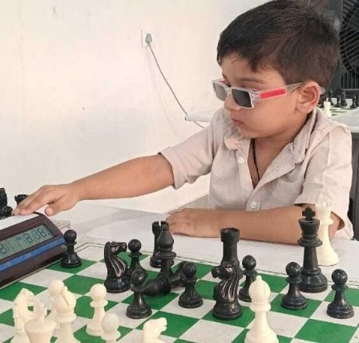
SARWAGYA SINGH KUSHWAHA (India) at three years
seven months has become the youngest FIDE rated player
ever after winning 5 of 8 tournament games and achieving
a Rapidplay rating of 1572 (minimum rating required 1400).
His father introduced him to chess when he was about 30
months old and says that what separates him from other kids
of his age is his patience to sit at the board and not get restless.

IM FAUSTINO ORO (Argentina) is now one step closer
to becoming the youngest ever GM (Grandmaster) after
gaining his second of three norms with an impressive
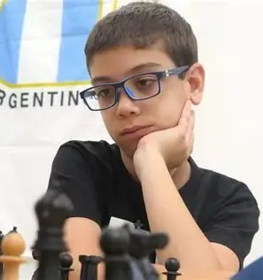
5.5/9 at the Szmetan-Giardelli Masters in Buenos Aries,
a half point behind the winner, Aryan Tari (Norway).

The AUSTRALIAN JUNIOR CHAMPIONSHIPS
will be held 17-25 January 2026 in Canberra.
Registration closes January 12
(australianjuniorchesschampionship2026.org).

SOLUTION: Facing a seemingly winning attack Black plays
1…Rxh3+!! After 2.Kxh3 Qh1+ 3.Kg3 Black continues to
jettison his pieces with 3…Nh5+! 4.gxh5 5.Qf3+! 5.Kh2
Qg2+! and it’s Stalemate after either 6.Kxg2 or Rxg2.

