CHESS January 3, 2026 David Ellis 04529798607 ellisd19@bigpond.com

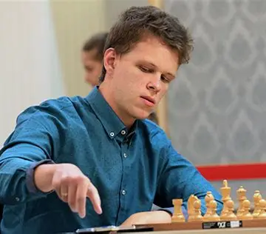
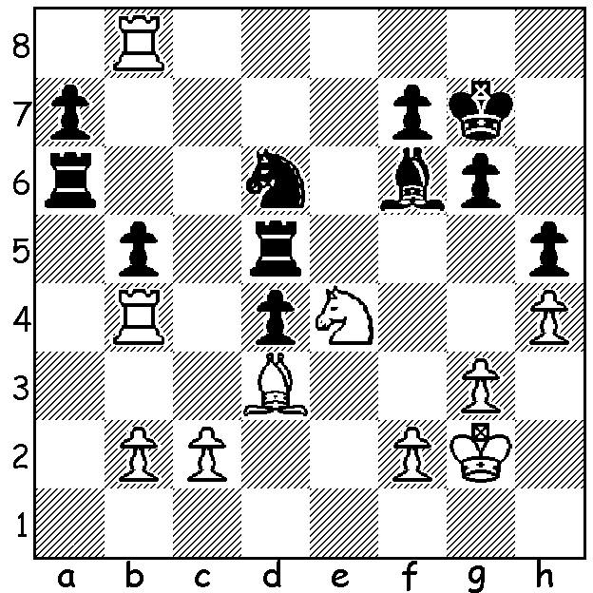

Vladislav Artemiev vs Vladislav Artemiov
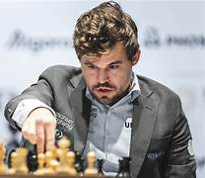
Daniil Lintchevski 2017:
White wins material (3 moves).

MAGNUS DOES IT AGAIN
Norwegian Magnus Carlsen this week became FIDE World Rapid
Champion for the sixth time after finishing a full point ahead of
the field in Doha, Qatar, scoring 10.5/13, losing only to Russian
Vladislav Artemiev. Magnus put aside his ill feeling towards FIDE
to compete after being fined last year for incorrect attire. Second
to fifth were Artemiev, Arjun Erigaisi (India), Hans Niemann
(USA) and Leiner Dominguez (USA) with 9.5. World champion Magnus Carlsen
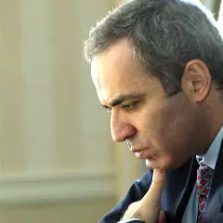
Gukesh Dommaraju (India) scored 8.5 and Australia’s only
representative IM James Morris scored 5.5. The tournament
with a time control of 15 min + 10 sec had 247 entries. The
championship was first played in 2012 with other winners being
Sergey Karjakin (Russia), Shakhriyar Mamedyarov (Azerbaijan),
Vasyl Ivanchuk (Ukraine), former world champion Viswanathan
Anand (India), Nodirbek Abdusattorov (Uzbekistan) and, last
year, Russian Volodar Murzin. Next week a report on the World
Blitz Championship which is played after the Rapid.

CHESS ON THE LARGE AND SMALL SCREENS Garry Kasparov
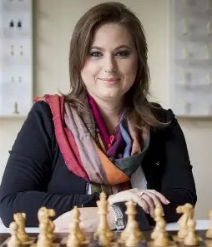
REMATCH, a compelling portrayal of the dramatic 1977
match between world champion Garry Kasparov and IBM’s
supercomputer Deep Blue, is being streamed in six episodes
on Channel 10.
QUEEN OF CHESS is a documentary about Hungarian
chess prodigy Judit Polgar who reached a peak rating of
2735 placing her 8th in world rankings. The film will be
premiered at the 2026 Sundance Film Festival and will
be available later on Netflix.

Judit Polgar

The AUSTRALIAN JUNIOR CHAMPIONSHIPS
will be held 17-25 January 2026 in Canberra. Registration closes January 12
(australianjuniorchesschampionship2026.org).

SOLUTION: 1.Rg8+! (deflection) 1…Kxg8 2.Nxf6+ Kg7 3.Nxd5. Perhaps the greatest achievement of Artemiev, aged 27, was his victory in the 2016 Russian Blitz Championship with a score of 18/22, 2.5 points ahead of second.

