CHESS January 10, 2026 David E;llis 04529798607 ellisd19@bigpond.com
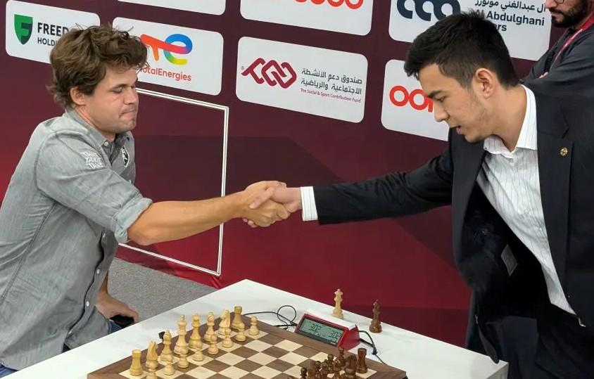
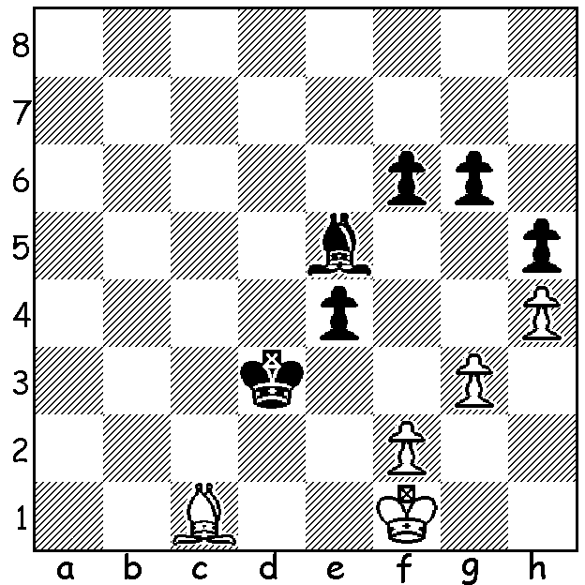

Nodirbek Abdusattorov Carlsen (W) vs Abdusattorov (B)
vs Magnus Carlsen
How does Black break
through?

THE CREAM ALWAYS RISES TO THE TOP
The FIDE World Blitz Championship (235 players) was played in Doha, Qatar, 29-30 December following the World Rapid, won for the sixth time by World No 1 Magnus Carlsen (Norway). After the first day of the Blitz Carlsen faced an uphill battle to be one of the four finalists with Arjun Erigaisi (India), Maxime Vachier-Lagrave (France) and Fabiano Caruana (USA) leading with 10/13 and with another six players on 9.5 while Carlsen was one of a host of players on 9 (losses to Erigaisi and Caruana). The second day started badly with a further loss before a run of four wins and a final round draw with Nodirbek Abdusattorov (Uzbekistan) saw Carlsen finish 3rd on 13.5, behind Erigaisi (15) and Caruana (14) and ahead of Abdusattorov (13). In the semi-finals he defeated Caruana 3-1 (+2 =2) to reach the final against Abdusattorov, who had defeated Erigaisi 2.5-0.5. Again Carlsen fell behind after losing the first game before coming out victor 2.5-1.5, his ninth World Blitz title. The time control was 3min + 2sec and while there were a number of outright blinders (to which Carlsen was not immune) it was amazing to see the overall standard of play with some games given an accuracy rate of 98% by top chess machines. The need to move almost instantaneously creates additional problems with Carlsen twice knocking over pieces, resulting in losing one game on time while resetting the pieces and another by default after he had pressed his clock before completing the resetting of the position*. Carlsen can now boast 20 titles encompassing Classic, Rapid and Blitz championships.
*Many years ago I was playing in a Lightning tournament in Leederville against the late Mary Thomson with a mate in one but with my flag about to fall. In my haste to move my queen flew out of my hand across the hall. I immediately picked up a queen from the neighbouring board to administer mate before returning it to its rightful place with a quick apology.

SOLUTION: 1…e3! 2.Bxe3 Bxg3+ leads to an easily won K + Ps ending. White played 3.Bg5 but resigned after 3…fxg5. Carlsen’s superb endgame play is an important factor in his successes.

