CHESS January 17, 2026 David Ellis 04529798607 ellisd19@bigpond.com

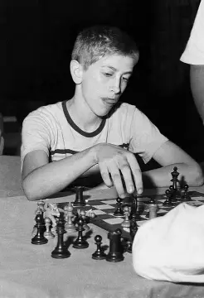
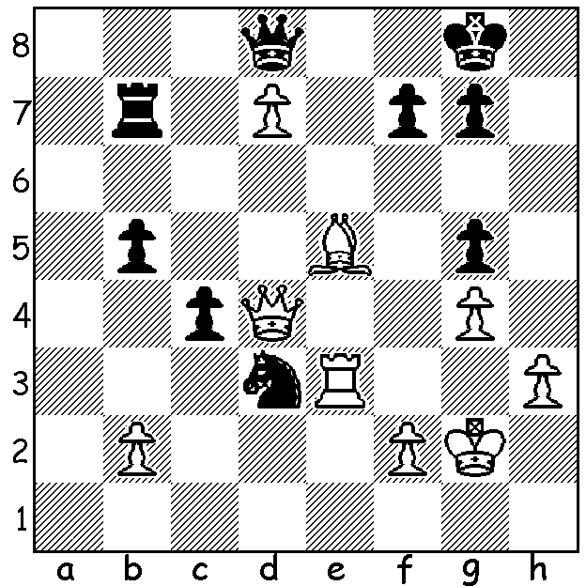

Bobby Fischer vs
Antillo Di Camillo 1956
White wins quickly. A young Bobby Fischer

FIDE READMITS RUSSIA
In February 2022 FIDE condemned the Russian invasion of Ukraine and banned Russia and Belarus from hosting FIDE tournaments, their teams were barred from playing in FIDE events, individuals had to play under the FIDE flag and any player known to support the invasion was also banned. However last month a vote at FIDE General Assembly passed motions which would permit Russian and Belarusian teams to compete in FIDE team events but do not restore the right to display national flags with the exception of youth and junior teams. These decisions are being challenged by a group of European countries, Ukraine, England, Norway, Estonia and Germany.
While on the subject of Russia, the most recent ratings show how far Russia has fallen with no Russian in the top 20 (Ian Nepomniachtchi is 23rd). A comparison with the first ratings put out by FIDE is very striking with the then USSR dominating:
July 1971 December 2025
1. Bobby Fischer USA 1. Magnus Carlsen Norway
2. Boris Spassky USSR 2. Hikaru Nakamura USA
3. Viktor Korchnoi USSR 3. Fabiano Caruana USA
4. Bent Larsen Denmark 4. Vincent Keymer Germany
5. Tigran Petrosian USSR 5. Arjun Erigaisi India
6. Lajos Portisch Hungary 6. Anish Giri Netherlands
7. Mikhail Botvinnik USSR 7. Alireza Firouzja France
8. Efim Geller USSR 8. Praggnanandhaa India
9. Lev Polugaevsky USSR 9. Wei Yi China
10. Mikhail Tal USSR 10. Dommaraju Gukesh India
USSR players include the then world champion, Spassky, and three former world champions in Petrosian, Botvinnik and Tal. Of the USSR players, Petrosian was Armenian and Tal Latvian.
Reasons for Russia’s decline:
- the loss of state-sponsored subsidised systems to promote chess after the collapse of the Soviet Union;
- increase in access to chess knowledge worldwide via computer;
- many players and coaches have emigrated from Russia, moves accentuated by the war against Ukraine;
4. the influence of Bobby Fisher in USA and Vishy Anand in India

SOLUTION: 1. Bc7! (clearance sacrifice) 1…Rxc7 2.Re8+ (Fischer was 13 at the time).

