CHESS January 24, 2026 David E;llis 04529798607 ellisd19@bigpond.com

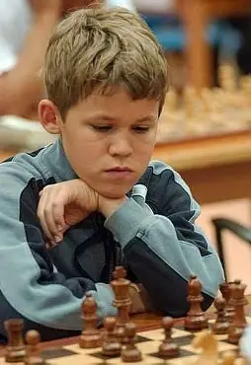
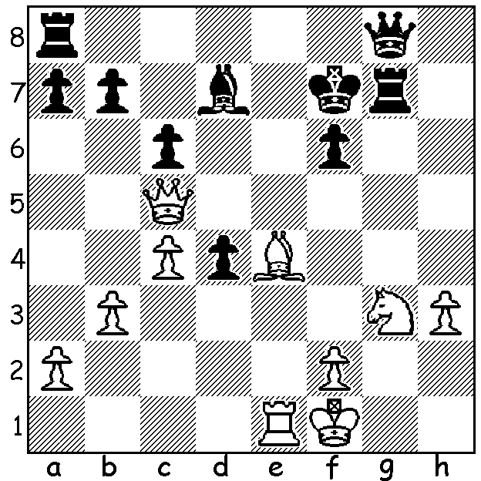

Magnus Carlsen vs
Helgi Gretarsson 2003.
White wins quickly.

THAT WAS THE YEAR IN WA CHESS
This week a rundown of the major tournaments in WA for 2025.
WA Champion was IM Patrick Gong. Patrick achieved a clean sweep by winning all the other main titles, the WA Rapid, the WA Allegro and the WA Blitz (the Blitz after a play-off with Ashvin Balavignan).
The WA Grand Prix which consisted of a combination of Classic, Rapid and Blitz, 8 tournaments in all, was monopolised by two players. Jessie De Guzman and Ricky Huang who took advantage of the non-regular participation of Perth’s leading players to scoop the pool with Jessie winning the Open and coming second in the Major (Under 1850 rating) while Ricky was runner-up in the Open, first in the Major and first in the Minor (Under 1550) with Aidan Malik second.
The Perth Club had a very full calendar with the club’s championship won by Victor Spirin (7.5/9), just ahead of Jacob Gibson (7).
Kathryn Hardegen, for many years WA’s leading female, won the Southern Suburbs Championship with 6/7, closely followed by Stijn Verlinden in 5.5 and David King, the only unbeaten player, on 5.
Tournament first places are now a very occasional happening for me but I did win the 2025 Metro Championship with 6.5/9, the first time I’ve had my name on the trophy since 2004 when I shared top spot with Adam Haasse. Second were Andras Szijarto and Michael Kueh (both 6).
Chess is thriving with a number of other clubs including Swan Valley, UWA, Kingsley and Bunbury offering opportunities to play either tournament or friendly games (information is on cawa.org.au). I welcome information from any club wishing to be promoted here (ellisd19@bigpond.com).
Outside of WA, the 2026 Australian Championship, played at the University of Sydney was won by Queenslander Yi Liu with 9/11 with 15-year-old Tedric Li from Victoria second (8.5).

SOLUTION: 1. Bg6+! (clearance, interference and deflection sacrifice): if 1…Kxg6 2.Qh5#: if 1…Rxg6 2.Qe7#. Magnus, 2025 Player of the Year, was 12 at the time.

I have decided to add a game of my own every week or so with one game from each year beginning in 1984 when I was 13. I only learnt to play when I went from the Scilly Isles to boarding school in Truro, Cornwall, after passing the 11+ exam. The school had a good reputation for chess and competed in the Cornish League for clubs throughout the county. (GM Michael Adams was a student there.) There was no coaching provided but I did make friends with a boy in my class, Charles Cowlrick, who was a very promising player who had learnt the game before coming to the school and with whom I spent much of my free time playing chess. At 13 during the Easter holidays I played in my first tournament at the West of England Congress, competing in the Junior (Under 18) Championship. Below is my sole win of five games played (2/6, +1, +1bye, -4).

D Ellis vs P Nash, April 17, 1954 (Queens Gambit Declined)
1.d4 d5 2.c4 e6 3.Nc3 Nf6 4.e3 Bb4
5.Bd2 0-0 6.a3 Be7 7.Nf3 Nbd7 8.Bd3 Re8
9.cxd exd 10.Bb1 c6 11.Qc2 Bd6 12.Ng5 Nf8
13.0-0 Ng6 14.Re1 Bd7 15.Ba2 Ng4 16.f4 Nf6
17.g3 h6 18.Nf3 Re7 19.Bb3 Ne4 20.Nxe4 dxe4
21.Ne5 Bxe5 22.dxe5 Bf5 23.Bb4 Rd7 24.Ba2 Ne7
25.Bc4 Rc8 26.Qb3 Nd5 27.Rad1 c5? 28.Bxd5 cxb4
29.Bxf7+! Kf8 30.e6 Rxd1 31.Rxd1 Qe7 32.Rd7 Qc5
33.Qxb4 Qxb4 34.axb4 Rc1+ 35.Kf2 Rc2+ 36.Ke1 Rc1+
37.Kd2 Rh1 38.Kc3 Rxh2 39.Rd8+ Ke7 40.Re8+ Kd6
41.Rg8 g5 42.fxg hxg 43.Rxg5 Bxe6? 44.Rg6 Re2
45.Rxe6+ Kc7 46.Rxe4 & wins

