CHESS January 31, 2026 David E;llis 04529798607 ellisd19@bigpond.com

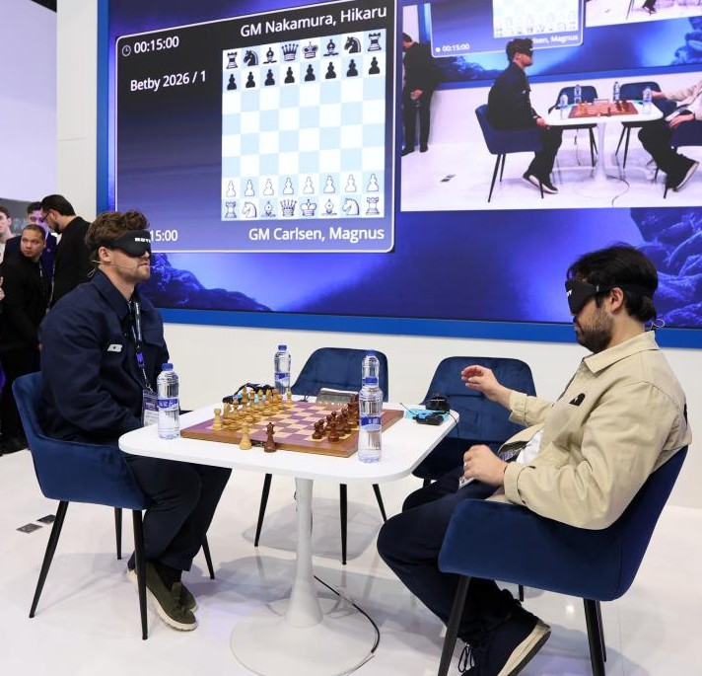
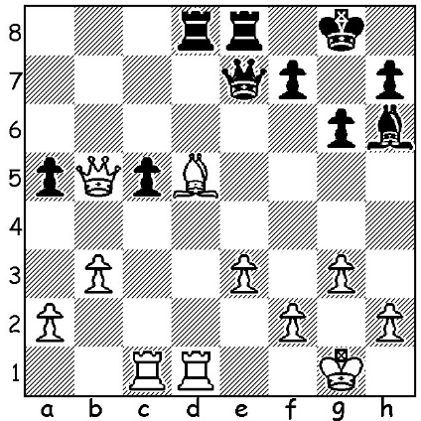

Magnus Carlsen vs Hikaru Nakamura
(Blindfold 2026):
How does Black force a draw?

BLINDFOLD DISPLAY HIGHLIGHTS CHESS
The world’s two highest ranked players, Magnus Carlsen and Hikaru Nakamura, showed off their amazing skills last week in a blindfold game at ICE, Barcelona, the world’s largest exhibition for the gaming and betting industry. Carlsen attended as a guest of Betby, one of his sponsors since 2024. Levy Rozman, also known as GothamChess, the world’s most well-known Chess Influencer, was also in attendance. The game had a time limit of 15 minutes for each player (no increments) with Carlsen drawing White. The customary handshake proved a difficulty with the assistant, sitting at the board at right angles to the players to make the moves as they were called out by the players, having to help their extended hands connect. Carlsen played one of his favourite openings in fast chess, the Nimzovitsch Attack (Nf3 / b3 / Bb2/ e3) and gained a positional advantage but by winning a pawn he allowed Nakamura a clever combination involving a piece sacrifice followed by an exchange sacrifice (R for B) to expose White’s king and force a draw by perpetual check. Engine assessment of the game gave each player a remarkable 96% accuracy score. After the game the two players and Rozman interacted with the audience in a Meet and Greet before taking on a succession of opponents from the audience.
Some good news for chess fans is that Carlsen intends to play more Classic Chess during 2026 than he did in 2025 including Norway Chess and the Olympiad. Carlsen gave up the world title in 2023 citing lack of motivation and a desire for new chess challenges beyond Classic Chess and his participation in Classic events has become less and less frequent.

SOLUTION: 1...Bxe3!! 2.fxe3 Rxd5! 3.Rxd5 Qxe3+ & the game concluded 4.Kg2 Qe4+, 5.Kf2 Qe3+ 6.Kg2 Qe4+ 7.Kh3 Qe6+ 8.g4 Qe3+ 9.Kg2 Qe4+ 10.Kg3 Qe3+ 11.Kg2 Qe4+
12.Kg3 =.

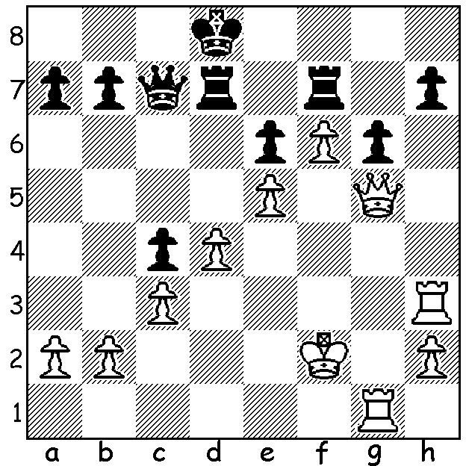
MY GAME A YEAR - 1955

I had discovered the Stonewall Attack with its
attacking opportunities against Black’s king.
Here’s one finish with the system from a game
in the Cornish League, Truro School vs
Falmouth. Black had tried to run his king out
of danger from g8. What is White’s next move?

Ellis (Cornwall) vs Hendy (Devon)
Junior County Match Bd 5
Stonewall Attack
1.d4 d5 2.e3 e6 3.Bd3 Nf6
4.f4 g6 5.Nf3 Bg7 6.0-0 0-0
7.Ne5 Nbd7 8.Nd2 c6 9.Rf3 Qb6
10.Qe1 c5 11.c3 Qc7 12.Qh4 cxd
13.exd Ne8 14.Rh3 Ndf6 15.g4 a6
16.Ndf3 b5 17.Bd2 Ra7 18.Ng5 h5
19.gxh Nxh5 20.Kh1 Nd6 21.Rg1 Nf5
22.Bxf5 exf5 23.Ngxf7! Rxf7 24.Rxg6 Nf6
25.Qh8#

From position – 1.Qxg6! & if hxg6 2.Rh8 mates.

