CHESS February 7, 2026 David E;llis 04529798607 ellisd19@bigpond.com


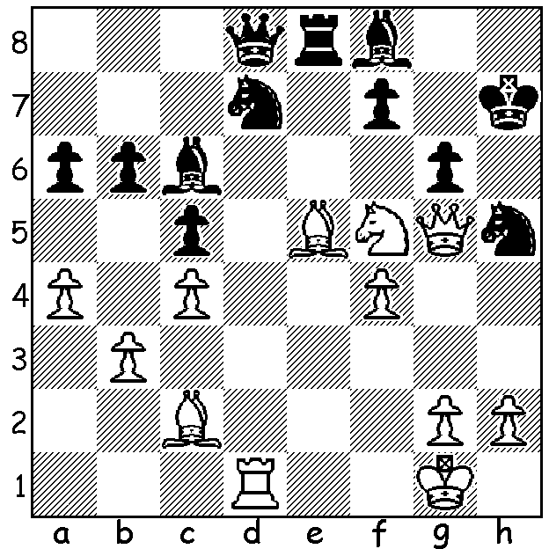

Nodirbek Abdusattorov
vs Babur Sattarov 2014
White, a piece down, mates in 5 Abdusattorov
(too difficult? clue in report).

FOURTH TIME LUCKY FOR ABDUSSATOROV
The annual Tata Steel Chess at the coastal village of Wijk aan Zee has been called ‘the Wimbledon of Chess’. Begun in 1938 the Masters event has had many famous winners with Magnus Carlsen (8 victories) and Vishy Anand (5) the most successful. Clue: very unusual square for the mating piece in the middlegame. Although missing the world’s top three players, Carlsen, Nakamura and Caruana, all scheduled to play in the Freestyle (Fischer Random) World Championship later this month, the event this year had a field of fourteen leading Grandmasters including the world champion Gukesh Dommaraju and last year’s winner Praggnandhaa. Winner of the Masters this year was 21-year-old Uzbek Nodirbek Abdusattorov with 9/13. Abdusattorov had experienced a number of disappointments previously, leading by a half point in 2023 before losing the final round, coming equal first in 2024 before losing a play-off and going into the final round in 2025 with a chance of first. Runner-up with 8.5 was fellow Uzbek 20-year-old Javokhir Sindarov, winner of the 2025 World Cup, while Jorden Van Foreest (Netherlands), Hans Niemann (USA) and Vincent Keymer (Germany) were next with 7.5. The youngest in the event was 14-year-old Yagiz Erdogmus (Turkey) who scored 7.

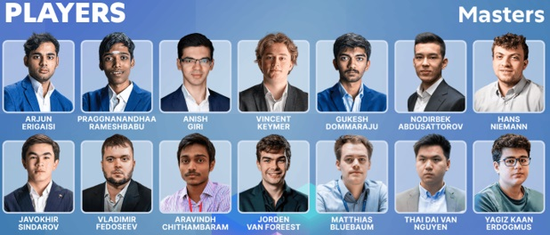

WA’s GRANDMASTER TO COMPETE IN BALLARAT
The 60th Begonia Open will be held in Ballarat from 7 to 9 March with WA’s Temur Kuybukarov among the Grandmasters who have already entered. I played last year, gaining a senior prize, and can recommend the event. Organisers have put a limit of 300 players so anyone wishing to compete should enrol ASAP.

SOLUTION: 1.Qxh5+!! gxh5 2.Ne7+ Be4 3.Bxe4+ f5 4.Bxf5+ Kh6 5.Ng8#. Played when he was 9 or 10-years-old!

