CHESS February 14, 2026 David E;llis 04529798607 ellisd19@bigpond.com

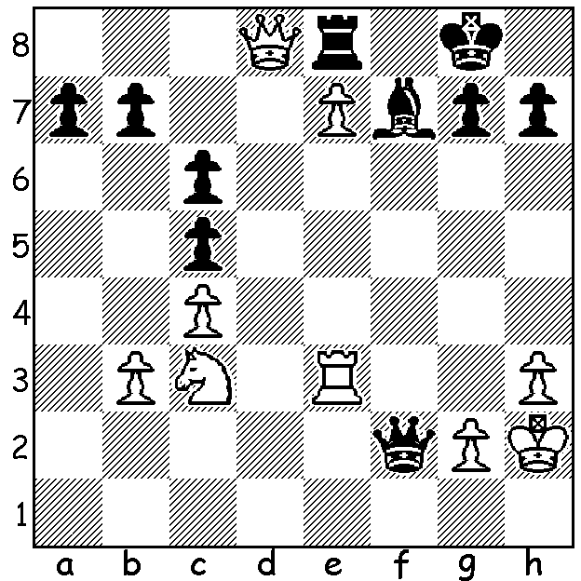
A B
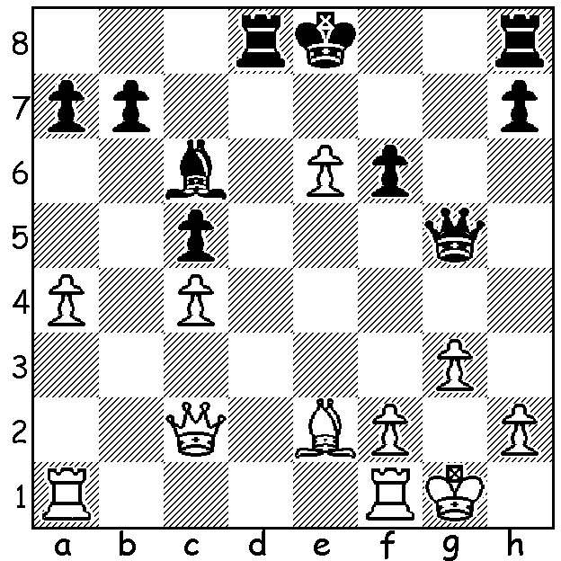

Colin Morris vs Mike Partis vs
Mike Partis Darryl Johansen
Australian Ch 1978: Australian Ch 1978)
Black to play and win White to play and win.
(4 moves). (3 moves).

DEATH OF FORMER CHESS ASSOCIATION PRESIDENT
A former Chess Association president and WA champion, Mike Partis, sadly passed away earlier this month. Mike was born in 1937 and first came to WA from Scotland in 1970 before returning in 1976 to take up permanent residence. He was for many years one of the foremost players in the state, winning the WA Championship three times as well as being a multi-winner of the WA Lightning and Allegro championships. For a number of years in the final decade of the last century he was very conscientious and effective president of the Chess Association.
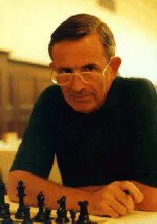
He combined his administrative work for the Association
and his participation in chess events with a high-level
academic career at the University of WA where he became
Head of the Department of Mathematics and Statistics and
Head of the Division of Science. He was honoured in 2003
by being awarded the Chancellor’s Medal for outstanding
contributions to the university. Leaving UWA he took up
the position of Director of the Secondary Education Authority,
a post he held for some years before his retirement.
On a personal note, I played against Mike on about a dozen
occasions and found him to be a fierce but friendly rival. One
particular game in the WA Championship between us lasted
over 10 hours of play and 122 moves spread over three days
(this was the time of sealed moves and resumptions later).
He was also my predecessor as chess columnist for the West.
His funeral will take place on Tuesday 17 February at 9.45
in the Norfolk Chapel, Karrakatta Cemetery. It is hoped many Mike Partis
members of the WA chess community will be able to attend to
pay their respects.

SOLUTION: A) The fork 1…Rd2 wins the bishop. 2.Bh5+ loses to 2…Qxh5! 3.Qxd2 Qf3 mating or winning the queen. (White played 2.Qxd2 but after 2…Qxd2 was soon mated.)
B) 1.Rf3 Qd4 2.Qxe8+! Bxe8 3.Rf8# Mike’s opponent, Darryl Johansen, became a GM in 1995 and won the Australian Championship six times between 1982 and 2002.

