CHESS 21 Feb 2026 04529798607ellisd19@bigpond.com

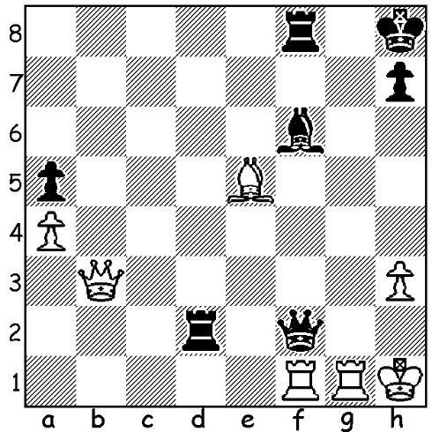

Faustino Oro vs
Marc Maurizzi Ivanchuk vs Oro

Tata Steel Challengers 2026
Can Black save the game?

YOUNGSTERS SHINE AT TATA STEEL
Mention was made two weeks ago of Yagiz Erdogmus from
Turkey who scored 7/13 at recent Tata Steel, Wijk aan Zee.
While his score didn’t get him into the prize list his score did
enable him to become at 14.16 years the youngest ever to be
rated in the world’s top 50.
Of other youngsters to achieve success, 15-year-old Andy
Woodward (USA) qualified for the Masters next year by
winning the Challengers with 10/13 after losing his first game.
He finished a half point ahead of Vasyl Ivanchuk (Ukraine), Yagiz Erdogmus

now a veteran at 56, who has played in 10 Masters at Wijk aan
Zee, winning on his first attempt in 1996.
It was a disappointing Challengers for 12-year-old Faustino
Oro (Argentina) who scored 7/13 and missed scoring his third
GM norm (by just a half point) and thus failing to become the
youngest GM ever. Carissa Yip, US Women’s champion four
times between 2021 and 2025, with a similar score, also just
missed out on a third GM norm.
A further outstanding junior was 15-year-old Christian
Gloekler (Germany) who won the top amateur event with a
score of 8.5/9 and qualifies for next year’s Challengers.

Carissa Yip
QUEEN OF CHESS
The film Queen of Chess, featuring the career of Judit Polgar, is now available on Netflix. Polgar, one of three chess playing sisters, succeeded in becoming at 15 the youngest GM of all time, beating the record of Bobby Fischer (surpassed a number of times since). She developed into one of the greatest players of her era, becoming the only woman to be rated in the world’s top 10 (8th her highest). Prominent in the series is her rivalry with the legendary Garry Kasparov.

SOLUTION: 1…Bxe5! 2.Rxf2 Rdxf2 3.Rg2 Rf1+ 4.Rf1 Rg2 draw. Any attempt by White to avoid the draw loses – eg 3.Rc1 Rg8! 4.Rc2 Rf1#.

