CHESS 28 Feb 2026 04529798607ellisd19@bigpond.com
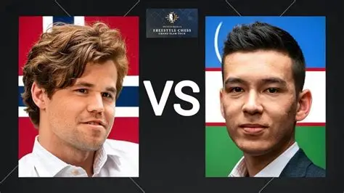
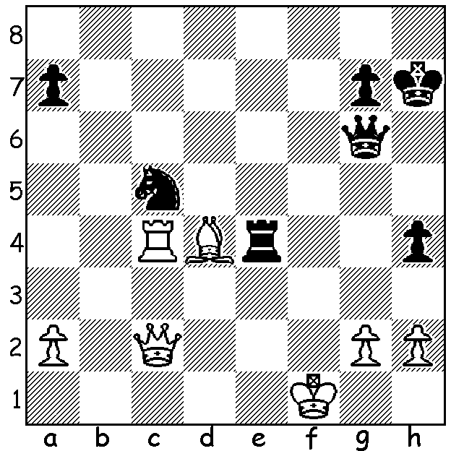

Nodirbek Abdusattorov
vs Magnus Carlsen Carlsen & Abdusattorov
World Freestyle 2026:
Black to play and win

ANOTHER WORLD TITLE FOR MAGNUS
The World Number 1, 35-year-old Norwegian Magnus Carlsen, recently added another world title, the FIDE Freestyle Chess World Championship, to his impressive tally. In all he has won world titles 21 times – 5 Classic World Championships before voluntarily giving up the title, 6 Rapid World titles, 9 Blitz World Championship titles and now the first official Freestyle championship (in Freestyle, also called CHESS960 and Fischer Random, the pieces are initially placed in one of the random 960 positions possible).The tournament, which was played in Weissenhaus, Germany, 13-15 February, began with an eight-player All-Play-All (10min + 5sec each) with the top four and bottom four going forward to separate Knock-Out finals (25min + 10sec each). Carlsen topped the round-robin with 4.5/7 before defeating Nodirbek Abdusattorov (Uzbekistan) 3-1 in the semi and Fabiano Caruano (USA) 2.5-1.5 in the final. In all Carlsen lost only once (to Arjun Erigaisi) in 15 games, although he was losing badly in Game 3 of the final against Caruana (which he won). He expressed satisfaction with his play apart from poor use of the clock which saw him down to a few seconds in a number of his games. Abdusattorov came 3rd by defeating Vincent Keymer (Germany, 4th) who had lost to Caruana in the semi. The bottom four players also played mini-matches to determine final places with Hans Niemann (USA) defeating Arjun Erigaisi (India, 6th) to come 5th and Levon Aronian (USA) defeating Javokhir Sindarov (Uzbekistan, 8th) to come 7th.

SOLUTION: 1…Nd3! (threat 2…Re1#) If 2.Qxd3 Re1+! wins the queen. White played 2.g3 but after 2…Qf5+ resigned (3.Bf2 Re1+ 4.Kg2 h3#). Had White played 2.Bf2 Nxf2 3.Kxf2 Qf5+ 4.Kg1 Re1# or 3.Rxe4 Nxe4 winning a piece.

