CHESS 7 March 2026 David Ellis 04529798607ellisd19@bigpond.com

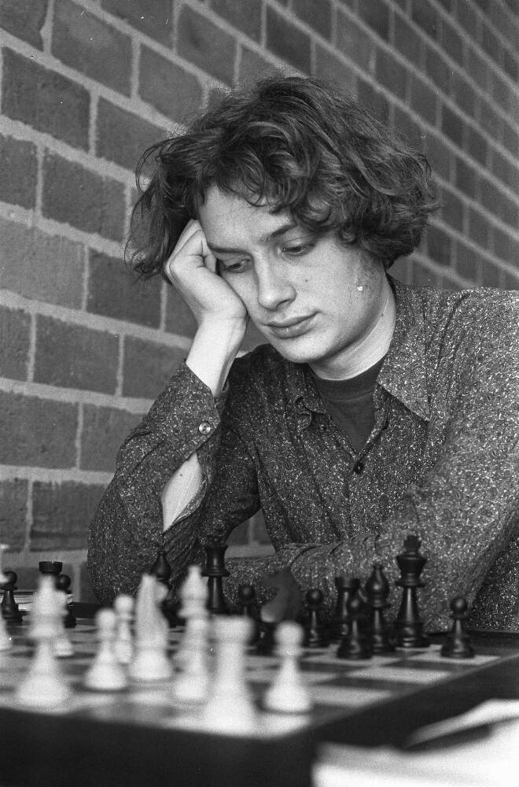
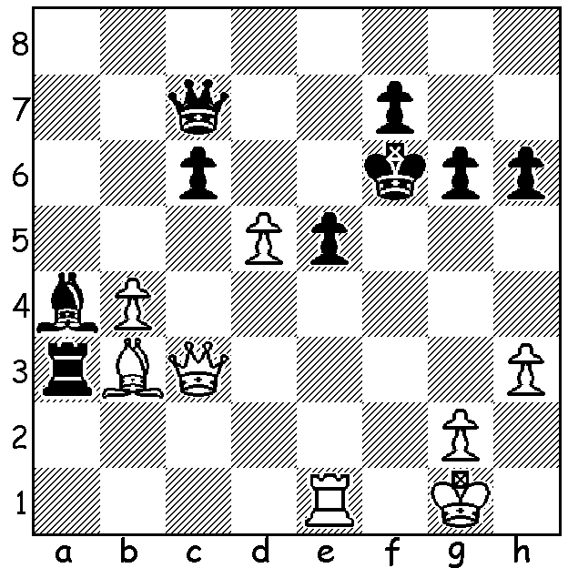

Jan Timman vs
Garry Kasparov 1985:
White to play and win
(move 1 is subtle). Jan Timman

DEATH OF FORMER WORLD NUMBER TWO
The Dutch GM Jan Timman died on 18 February aged 74. He was for many years a regular competitor in the Candidates, was Dutch champion nine times and represented the Netherlands on Bd 1 at 11 Chess Olympiads. His best years were between 1975 and 1995 and, during a time of USSR dominance, he earned the moniker ‘the Best in the West’ with his ranking in 1982 second behind only world champion Anatoly Karpov. He was also called the last of the Romantics with a dislike for chess engines, saying, ‘Professional Chess is now ruled by the computer. I think in these times I wouldn’t have become a chess professional player. Knowledge has become too important. You cannot live on talent alone’. He learnt to play at the age of eight with his early heroes and influencers being Botvinnik and Fischer. He came close to a match for the world championship against Garry Kasparov in 1993 when he reached the final of the Knock-Out Candidates before losing to Englishman Nigel Short 5.5-7.5 (+3 =5 -5) - the match is famous for Short’s amazing ‘Long King March’ where, in the middlegame, he moved his king from g1 to h6 to mate. Timman was an avid writer – for newspapers and magazines and author of several chess books. He presented a ten-part TV series, ‘Chess with Jan Timman’ which had a viewing audience of 300,000 - this in a country of less than 17,000,000. Timman was always a lover of the endgame, creating collections and compositions, with perhaps his most famous book being ‘The Art of the Endgame’. However he was a man with many other interests besides chess, very different from most leading players. He wrote on topics outside of chess such as an essay on the Russian novelist Fyodor Dostoevsky (‘Crime and Punishment’, ‘The Brothers Karamzov’), he visited art galleries, was a wine connoisseur and enjoyed the music of Bob Dylan and the Rolling Stones.

SOLUTION: 1.d6!! (clearing the bishop’s diagonal and deflecting the queen) 1…Qxd6 2.Qf3+ Ke7 3.Qxf7+ Kd8 4.Rd1 Ra1 (hoping for a swindle) 5.Qf6+! resigns.

