CHESS 14 March 2026 David Ellis 04529798607ellisd19@bigpond.com


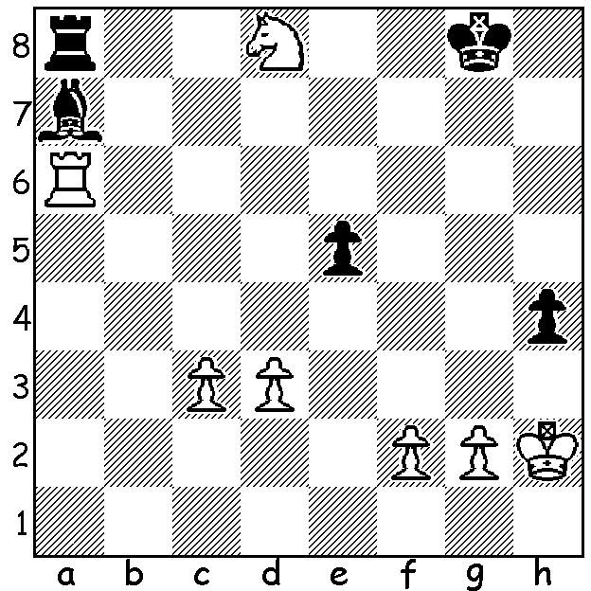

Aravindha Chithambaram
vs David Navara,
Prague 2026, Rd 9: Top players at Prague (front row L to R)
work out Black’s next move Maghsoodloo 2nd, Abdusattorov 1st
and White’s best reply. Chithambaram 3rd (2nd & 3rd on countback)

THIRD MAJOR SUCCESS FOR ABDUASATTOROV
Nodirbek Abdusattorov (Azerbaijan), aged twenty-one, has now won the last three major tournaments he has played in, the London Chess Classic (Nov-Dec 2025), the Tata Steel Chess Masters (Jan-Feb 2026) and last week the Prague Chess Masters, a tournament he previously won in 2024. In the Prague event, a ten-player round robin, Abdusattorov came from behind to win sole first with a Rd 8 win against David Navara and a final round draw against Hans Niemann, finishing with a score of 6/9 (+3 =6). One point behind on 5 were Parham Maghsoodloo (Iran), last year’s winner Aravindh Chithambaram (India) and Jorden van Foreest (Netherlasnds). It was an excellent result for Maghsoodloo, especially with thoughts of the US attack on his country, while there were mixed emotions for van Foreest who has now improved his world rating to 11th but who led throughout before losing his final two games. Other scores: Nodirbek Yakubboev (Azbek.) and David Navara (Czech.) 4.5, Vincent Keymer (Germany) and Hans Niemann (USA) 4, Gukesh Dommaraju (India) and David Anton (Spain) 3.5. For world champion Gukesh it was another disappointing result, languishing in sole last place for a number of rounds and gaining his only win in the final round.
The Candidates, an eight-player double round robin to determine a challenger to Gukesh begins on March 28 in Cyprus. Unfortunately Abdusattorov, although now the fourth highest rated player in the world, has not qualified. With the game more and more dominated by the young (Gukesh is 19), for Hikaru Nakamura (USA) at 38 this may be his last chance for the world title, and perhaps also for Fabiano Caruana (USA) and Anish Giri (Netherlands) both 31.

SOLUTION: Black seems in trouble, 2 pawns down and his bishop in danger to Nc6 after a king move. Not 1…Rxd8 (2.Rxa7 Rxd3 3.Rc7 with a likely win) but 1…e4!! (2.dxe? Bb8+ wins or 2.Kh3 exd 3.Rd6 Bxf2 with good drawing chances). White now played 2.Rxa7! (2...Rxa7 3.dxe) and eventually won.

