CHESS March 28, 2026 David Ellis ellisd19@bigpond.com 043979860

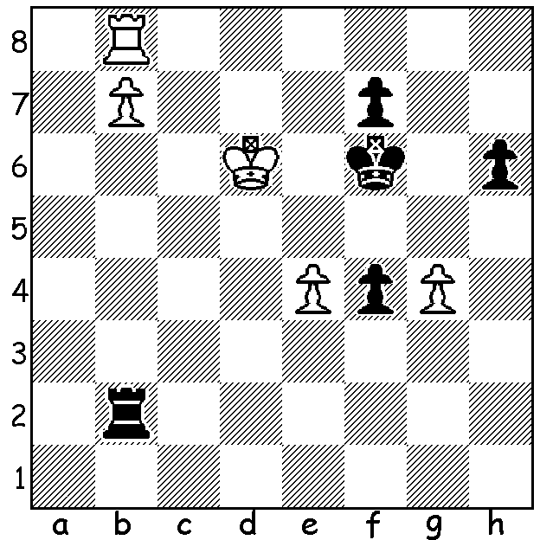

Magnus Carlsen vs
Zbynek Hracek 2007
White to play & win:

CARLSEN BEATEN AT RAPIDPLAY BY AMATEUR

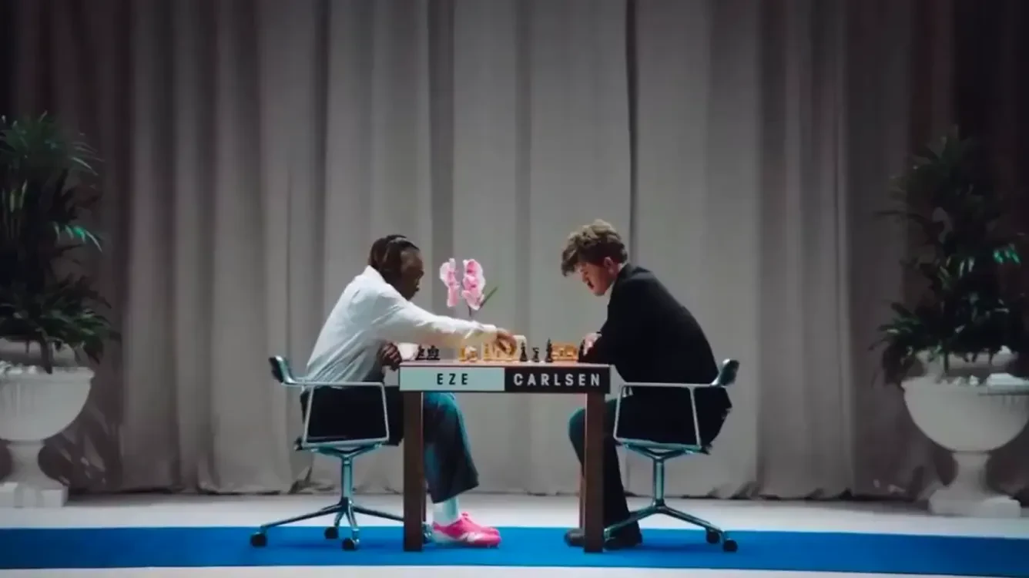
Last Sunday nearly 75 thousand spectators packed Stadium Australia in Sydney to cheer on the Matildas in their quest to win the final of the Womens Asian Cup final while over 3 million others were watching the
game on television. I am therefore featuring
soccer in this article with the news that
World No 1 Magnus Carlsen has been
beaten by an amateur in a rapidplay game
with the victor being Eberechi Eze, an
English international soccer player. When
not involved in training or playing football
Eze might well be seen at a chess board and
last year won an online chess competition,
the PogChamps 6, a celebrity tournament
organised by Chess.com. Before joining
Premier League leaders Arsenal this season Eze played for another London Premier League team, Crystal Palace, and scored regularly in the club’s 2025 FA Cup games, culminating in the final at Wembley where he scored the only goal of the game against Manchester City which gave Palace its first ever major trophy. And what about his win against Carlsen? It was in fact a scripted tv advertisement for a sports shoe brand.
Continuing the theme of Soccer and Chess, it is reported that Erling Haaland, a Norwegian international and goal scoring machine for Manchester City (over 350 goals for club and country), has become an investor in Norway Chess, backing the launch of the new Total Chess World Championship Tour. Haaland, with over 40 million followers on Instagram and now even more popular in Norway than Carlsen, claims chess is an incredible game, sharpening the mind with clear similarities to football - needing to think quickly, trusting one’s instincts and thinking several moves ahead.

SOLUTION: 1.Rg8 resigns (1...Rxb7 2.e5#)

My Unremarkable Chess Career, Year 2

David Ellis - B. E. Blandfield
West of England Junior Championship, Rd 2: 8 April 1955
Queens Gambit, Orthodox Defence
1.d4 d5 2.c4 e6 3.Nc3 Nf6
4.Bg5 Nbd7 5.Nf3 Be7 6.e3 0-0
7.Bd3 h6 8.Bh4 c5 9.cxd cxd
10.d6 dxc3 11.dxe7 Qxe7 12.bxc Qc5
13.Qb3 Nd5 14.c4 N5b6 15.0-0 Qd6
16.Bg3 Qe7 17.Bh4 Qc5 18.Rac1 Ne5
19.Nxe5 Qxe5 20.c5 Nd7 21.Bg3 Qg5
22.Bd6 Rd8 23.f4 Qd5 24.Qc2 Nxc5 ??
25.Bxc5 Qxd3 26.Rfd1 Qxc2 27.Rxd8+ Kh7
28.Rxc2 resigns

