CHESS April 4, 2026 David Ellis ellisd19@bigpond.com 043979860

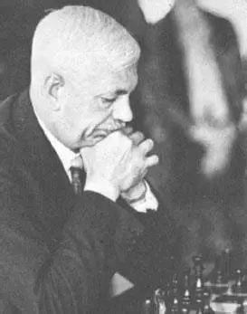
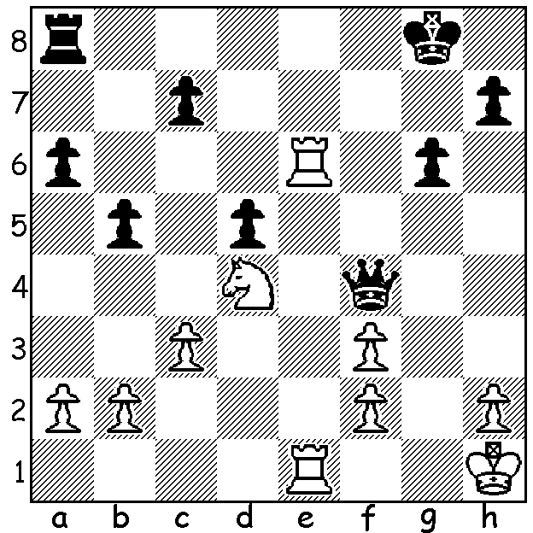

Sir George Thomas vs
Alfred Brinkmann 1929
White to play & win
(5 moves).
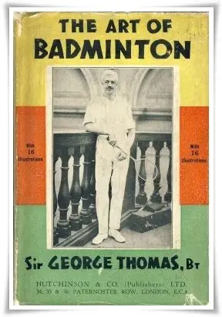
EXCELLING IN CHESS & OTHER SPORTS
Last week I highlighted the achievements of enthusiastic chess player
and English international soccer player Eberechi Eze. This week it’s
someone who arguably was the best of all chess players who excelled
at other sports. The name Sir George Thomas is known to chess
followers mainly for his loss to Edward Lasker in a game highlighted
by a queen sacrifice and subsequent lengthy king hunt. I have used
this game in three displays of Living Chess with the suicide of most of
White’s army to achieve the mate of the Black king.
Sir George (1881-1972) was an amateur chess player who won
the British Championship twice, 1923 and 1934. His crowning
achievement was equal first at the 1934/5 Hastings tournament with
Salo Flohr and Max Euwe (who was to take the world title from
Alexander Alekhine a few months after Hasting) where he defeated
one former world champion in Jose Capablanca and one future
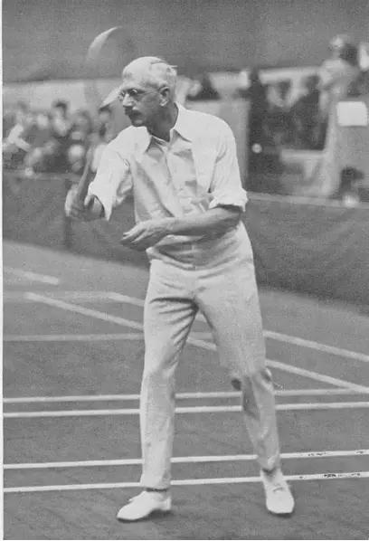
world champion in Mikhael Botvinnik. He represented England in
seven Chess Olympiads between 1927 and 1939 and was awarded
the International Master (IM) title in 1950.
But as impressive as were his chess accomplishments he gained
even greater success in another sport, badminton, where he was 21
times All-England champion (4 men’s singles, 9 men’s doubles, 8
mixed doubles) at a time when the All- England Championships
were considered the unofficial World Championships. He was co-
founder of the International Badminton World Federation and in his
honour the Badminton World Mens Championship (equivalent to the
Tennis Davis Cup) was named after him.
And that’s not all. In tennis he also reached the quarterfinals of
singles and the semifinals of the men’s doubles at Wimbledon. Truly
an amazing sporting career!

SOLUTION: 1.Re8+ Rxe8 2.Rxe8+ Kf7 (2…Kg7 3.Ne6+) 3.Rf8+! Kxf8 4.Ne6+ / 5.Nxf4.

My Unremarkable Chess Career, Year 3
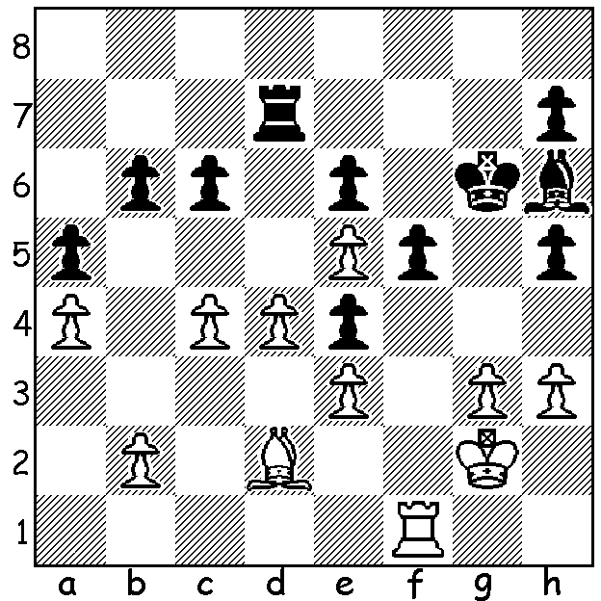
David Ellis - George Wheeler
West of England Minor, Rd 3: March 31, 1956
Stonewall Attack
Position after 30…Rd7

31.g4! hxg 31.g4! hxg 32.hxg fxg
33.Rf6+ Kg7 34.Rxe6 Rc7
35.Kg3 Bg5 36.Kxg4 h6
37.Kf5 Rf7+ 38.Kxe4 h5
39.Be1 h4 40.Bxh4 Bxh4
41.Rxc6 Bd8 42.e6 Re7
43.Rd6 Bc7 44.Rd7 Rxd7 45.exd7 Kf6
46.Kd5 Bd8 47.e4 Kf7 48.e5 Kf8
49.Kc6 Ke7 50.d5 resigns

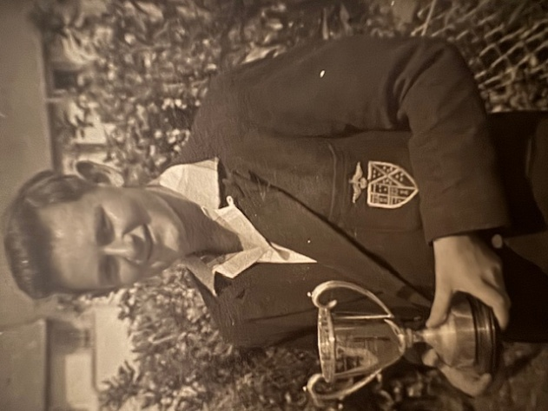
This year the West of England Chess Federation
introduced a Minor Championship for Juniors
Under 16. Wheeler led me by a half point so this
win was important to me and I went on to win the
event with 5/6 (+4 =2), my first tournament success.

