CHESS April 11, 2026 David Ellis ellisd19@bigpond.com 043979860

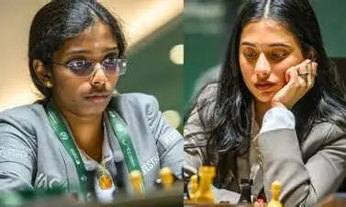
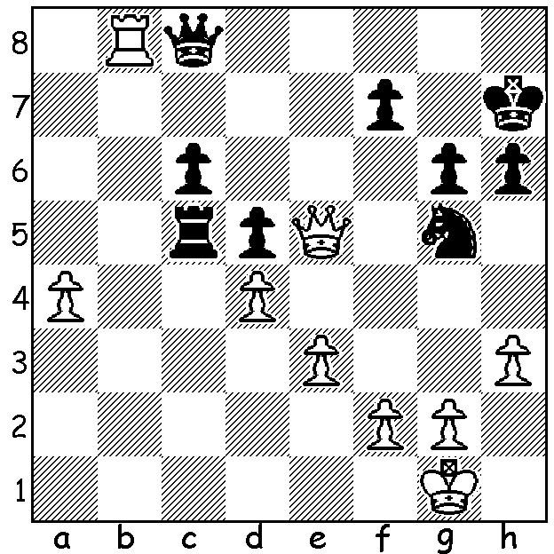

Divya Deshmukh vs Vaishali & Deshmukh
Vaishali Ramashbabu
Womens Candidates 2026:
How does Black save this
seemingly hopeless position?

WA GM HAS UNCHARACTERISTIC SLUMP IN CANBERRA
The Doeberl Cup, played over the Easter weekend in Canberra attracted 350 entrants. The tournament, named after its first sponsor Erich Doeberl, began in 1963 and has been the leading tournament in Australia (excluding Australian Championships) for many years. The main event, the Premier, had 60 players including GMs and IMs from both Australia and overseas. WA’s GM Temur Kuybokarov led after 5 rounds with 4.5 points but surprisingly fell away to lose three of his final four games, finishing well down with 5.5. Winner was defending champion 24-year-old Indian GM Guha Mitrabha with 7.5/9, closely followed by FM Alexis Vargas Arteaga (Columbia) on 7. The only other West Australian I could find in the lists was Adam Kelly, now living over east, who scored 4.5 in the Premier.

MAGNUS MISSES OUT IN GERMANY
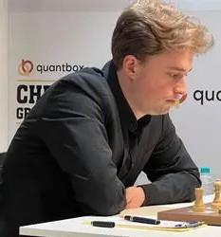
The main event at the Grenke Chess Festival, held in
Karlsruhe over Easter and named after the main sponsor,
Grenke AG, a German finance company, was the Grenke
Freestyle A (also called Fischer Random or 960 Chess),
played under Classic time controls with 310 contestants.
A number of players were in contention at the start of
the final round but quick draws among the leaders left
Vincent Keymer (Germany) and Maxime Vachier-
Lagrave (France) level on 7.5/9 with Keymer winning
thetitle on tie-break. Magnus Carlsen (Norway) and his
last round opponent Aryan Chopra (India) together with
five more players including Ian Nepomniachtchi (Russia)
and Nodirbek Abdusattorov (Uzbekistan) were a
half-point behind at the finish on 7.

SOLUTION: 1…Rc1+ 2.Kh2 Qxh3+!! 3.gxh3 Nf3+ 4.Kg2 Nxe5 5.dxe5 and the game between these two Indian WGMs finished in a draw. The Candidates and Womens Candidates, to find challengers to the world champion and women’s world championship, has been held in Cyprus. Full reports in next few weeks.

My Unremarkable Chess Career, Year 4

David Ellis - Charles Cowlrick
Cornish Junior Championship: June 18, 1957
Kings Indian Defence
1.d4 Nf6 2.c4 g6 3.Nc3 Bg7
4.e4 d6 5.g3 0-0 6.Bg2 Nc6
7.Nge2 e5 8.d5 Ne7 9.0-0 Nd7
10.Be3 f5 11.f4 Nf6 12.exf Nxf5
13.Bd2 Ng4 14.Qc1 Re8 15.h3 Nf6
16.fxe dxe 17.g4 Nd4 18.Ng3 h5?
19.gxh gxh? 20.Bg5 Qd6 21.Bxf6 Qb6
(21…Qxf6 22.Nxh5 or 21…Bxf6 22.Ne4)
22.Na4 Ne2+ 23.Kh2 Nxc1 24.Nxb6 axb6
25.Nxh5? Bh6 26.Raxc1 Bxc1 27.Rxc1 Rxa2
28.Rc2 Kf7 29.Bh4 Kg6 30.Ng3 Bf5
31.Rf2 Bd3 32.Be4+ Bxe4 33.Nxe4 Ra4
34.d6 cxd 35.Nxd6 Re6 36.Rd2 e4
37.Bg3 Rb4 38.Re2 e3 39.Kg2 Rb3
40.Nxb7 Rd3 41.Kf3 Kf5 42.Nd6+ Rexd6
43.Bxd6 Rxd6 44.Rxe3 and wins

cont: 44…Rd4 45.Rc3 Rh4 46.Ke2 Ke4 47.Kd2 Rf4 48.Kc2 Rf2+ 49.Kb3 Kd4 50.Rg3 Rh2 51.Rg4+ Ke5 52.Rh4 Rg2 53.Rh5+ Kd4 54.Rd5+ Ke4 55.Rh5 Kd4 56.Rd5+ Ke4 57.h4 Rg6 58.h5 Rh6 59.Kb4 Rf6 60.b3 Rh6 61.Kb5 Rf6 62.Ka6 Re6 63.Kb7 Kf4 64.Kc7 Rh6 65.Kd7 Kg4 66.Ke7 Kh4 67.Kf7 Kg4 68.Kg7 Rxh5 69.Rxh5 Kxh5 70.Kf6 resigns.

Cowlrick, in the same year as me, was Truro School’s top player so it was particularly pleasing to defeat him and win the championship.

