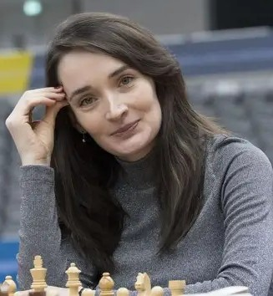
CHESS April 25, 2026 David Ellis ellisd19@bigpond.com 043979860 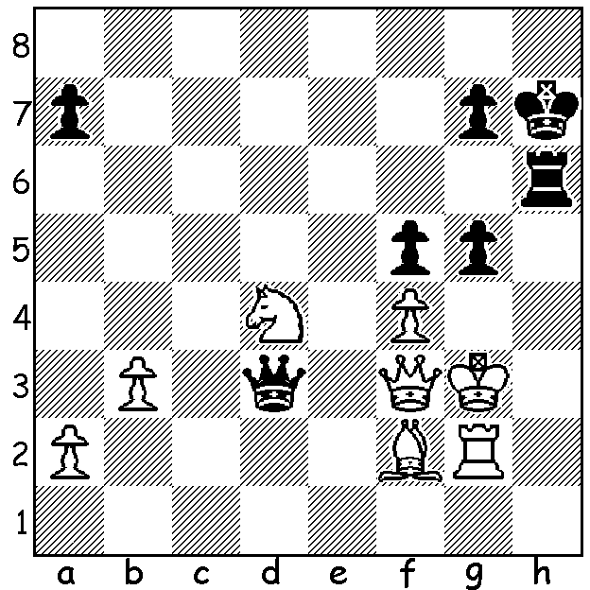

Tan Zhongyi vs
Kateryna Lagno Kateryna Lagno
Womens Candidates 2026:
Black to play and win.

PHOTO FINISH TO WOMENS 2026 CANDIDATES
In continuing the analogy of horse-racing, the Womens Candidates was far from the one-horse race the Candidates Tournament proved to be when 20-year-old Uzbek Javokhir Sindariv took the lead early and was able to ease up with a few draws in the second half and still win by 1.5 points. The women’s event, held in the same playing arena in Cyprus and run concurrently with the Candidates, was so close that there were frequent changes of leader and, at the start of the final round, six of the eight players were in with a chance of
first or equal first. The winner, who earns the right to challenge women’s world champion
Ju Wenjin (China), was 24-year-old Vaishali Rameshbabu (India), sister of Pragg who
finished a disappointing =6th in the Candidates. She was slow to start with four draws and
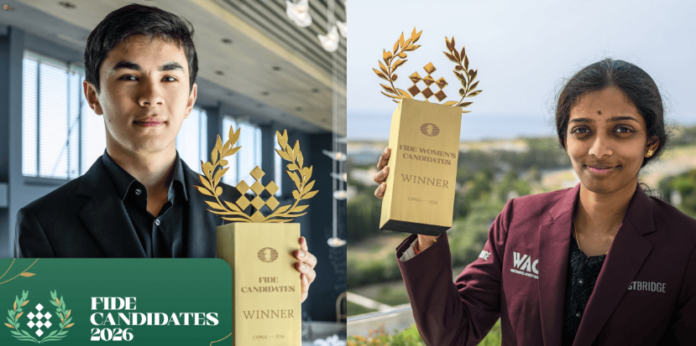
a loss in the first five rounds but then hit
her straps. She won her final game against
Kateryna Lagno (Russia) with co-leader
Bibisara Assaubayeva (Kazakhstan),
despite going all out for a win in a wild
game, unable to clinch a win, finishing
with a forced draw by repetition against
Divya Deshmukh (India). Scores: 1st
Vaishali 8.5/14; 2nd Assaubayrva 8;
=3rd Zhu Jiner (China) & Alexandra
Goryachkina (Russia) 7.5; 5th Anna Sindarov and Vaishali
Muzychuk (Ukraine) 7; 8th Lagno 6.5;=9th Divya Deshmukh & Tan Zhongyi (China) 5.5.) Anna Muzychuk, whose sister Mariya was women’s world champion 2015-16, was a late
replacement for Humpy Koneru (India) who withdrew after Cyprus had been a target in the Iran war with USA and Israel. Tan Zhongyi was women’s world champion 2017-18. (Readers might wonder why I refer to the Candidates rather than the Mens Candidates. It is because the Candidates is open to women as well as men though Judit Polgar has been the only woman to qualify for the Candidates.)

The BUNBURY OPEN will be played on May 2nd & 3rd. This tournament is open to non-CAWA members as well as members. Check details on cawa.org.au

SOLUTION: 1…g4!! (if 2.Qxd3 Rh3#); play continued 2.Rh2 gxf3 3.Rxh6+ gxh6 4.Nxf3 but the N & B were no match for the Q.

My Unremarkable Chess Career, Year 6
After leaving school and starting tertiary in Yorkshire I played much less chess. One trouble with evening games played with clocks with, say, 24 moves in an hour followed by 6 in 15 minutes was that games were often unfinished and were then adjudicated if a decision was not agreed. Here’s one such game:

D. Ellis vs M Hammett
Sheffield League, October 1959
French Defence Irregular
1.e4 e6 2.f4 Nc6 3.Nc3 d5
4.e5 f6 5.exf gxf 6.Qh5+ Ke7
7.Nf3 Nb4 8.Bd3 Nxd3+ 9.cxd3 Bd7
10.b3 Qe8 11.Qh4 Qg6 12.0-0 Re8
13.f5 Qxf5 14.Qb4+ Kf7 15.Qxb7 Bd6
16.d4 Qg4 17.Ba3! Bf4 18.Qxa7 Ne7
19.Ne5+? fxe5 20.dxe Nf5 21.Qxc7 Rhg8
22.Qxe7+!! Re7 23.Qxe7+ Nxe7 24.Rxf4+ Qxf4
25.Rf1 Qxf1+ 26.Kxf1 Nc6 27.Bd6 Rg5
Draw Agreed
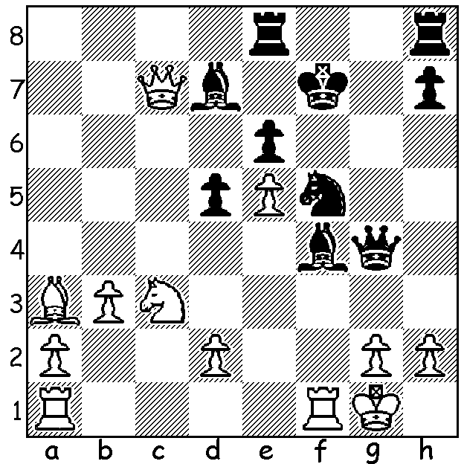
Position after 21.Qxc7.
Play continues 21…Rhg8 (21…Rd8 22.Nxd5!
exd5 23.Rxf4! Qxf4 24.e6+ Kxe6 25.Qxf4)
22.Qxd7+! Re7 23.Qxe7+! Nxe7 24.Rxf4+!
Qxf4 25.Rf1 Qxf1+ 26.Kxf1 Nc6 27.Bd6
DRAW agreed though Black’s united passed
pawns seem hard to stop.

